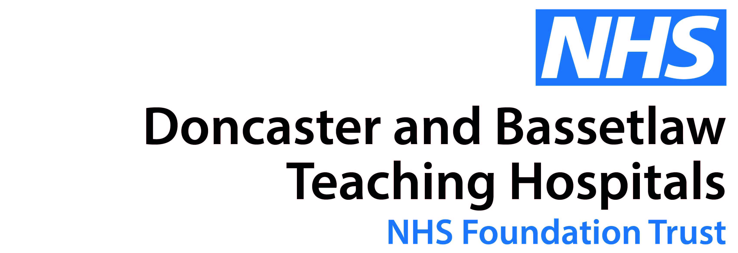
Form D – Mid-year review
Name: Date:

Job title: Line-manager:

Progress against objectives:
- Has anything changed since your appraisal? Do your objectives need to be revised? Think about your responsibilities, priorities and workload.
- Bring any evidence to show the changes, and be prepared to discuss with your manager.
- Have you already achieved some of your objectives? You will need to review and develop more stretching targets.
Objective | Progress update/Agreed changes to objective
How are you developing?
- Is there anything hindering or preventing your development needs?
- Bring any evidence, and be prepared to discuss with your manager.
- Has your training and development helped you to undertake your role more effectively?
- Have you identified any other development needs?
Objective | Achievement of your training and development (including any hindrances/barriers) | Additional Support

