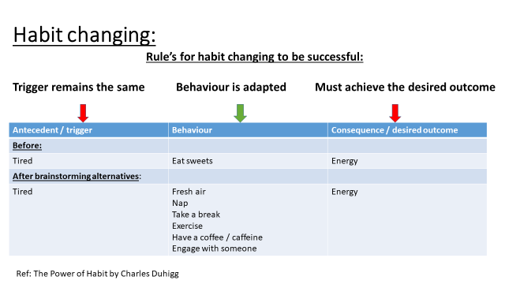

|  |  |  |
| --- | --- | --- |
| A | B | c |
| **Before:** |  |  |
|  | **After Brainstorming alternatives**: |  |
| **Before:** |  |  |
|  | **After Brainstorming alternatives**: |  |