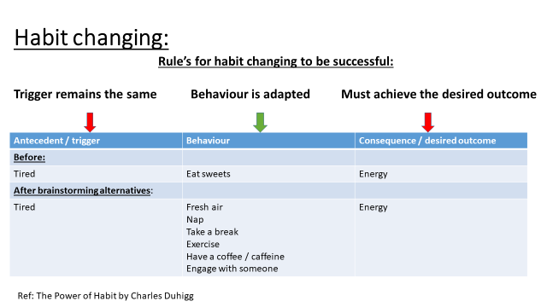

A | B | c
Before:

 | After Brainstorming alternatives:
Before:

 | After Brainstorming alternatives:

