Recommended Reading
Free resources online:
Diabetes UK - Food psychology, at: https://www.diabetes.org.uk/Guide-to-diabetes/Enjoy-food/Eating-with-diabetes/food-psychology
Address your stress, at: https://mhfaengland.org/mhfa-centre/campaigns/mhaw2018/
Dealing with Distress, at: https://www.getselfhelp.co.uk/docs/DealingwithDistress.pdf
Beat Eating Disorders Website – Emotional Eating, at: https://www.beateatingdisorders.org.uk/

South Yorkshire Eating Disorders Association: https://www.syeda.org.uk/

Free anxiety and depression course: https://www.reed.co.uk/courses/understanding-anxiety-depression-and-cbt/193172#/courses/free/health-care

Free courses: https://www.reed.co.uk/courses/free/health-care

Support groups:

Beat Eating Disorders- online support groups, at: https://www.beateatingdisorders.org.uk/support-services/online-groups

Diabetes peer support group: https://www.diabetes.org.uk/how_we_help/local_support_groups/peer-support

Doncaster Bariatric Support and Advice group - Facebook.

Overeaters Anonymous UK (a 12-step programme, similar to Alcoholics Anonymous): www.oagb.org.uk

Anxiety UK, online therapy and support group: https://www.anxietyuk.org.uk/get-help/anxiety-uk-courses-and-groups/

Beyond Chocolate (free online support forum): www.beyondchocolate.co.uk

Books / programmes:

These following books are all available in audio book format, electronic download and paper back (from i-tunes, Audible, Amazon, Kindle, and try your local library). They can be listened to when driving, having a bath, in bed, whilst ironing, walking etc. They may not be everyone’s cup of tea, but definitely worth a try. It may be useful to listen to some of them more than once, as it doesn’t always go in first time. Enjoy!

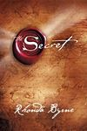 The Secret is a best-selling 2006 self-help book written by Rhonda Byrne, based on the earlier film of the same name. It is based on the law of attraction and claims that positive thinking can create life-changing results such as increased happiness, health, and wealth.
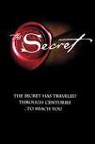 The Secret. 2006 ‧ Documentary ‧ 1h 30m. Available on Netflix and U-tube.

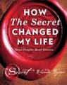How The Secret Changed My Life presents a selection of the most heart-warming and moving stories in one inspirational volume.
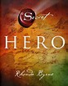 Hero, self-help book written by Rhonda Byrne the fourth in The Secret Book Series, was released in 2013
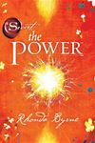 The Power is a 2010 self-help and spirituality book written by Rhonda Byrne. It is a sequel to the 2006 book The Secret. The book is based on the law of attraction and claims that positive thinking can create life-changing results such as increased happiness, health, and wealth.

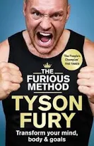 The Furious Method. Transform Your Body, Mind & Goals.

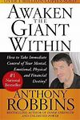 Awaken the Giant Within : How to Take Immediate Control of Your Mental, Emotional, Physical and Financial Destiny! Paperback – November 1, 1992 by Tony Robbins (Author).

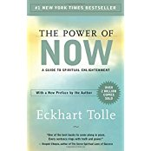The Power of Now: A Guide to Spiritual Enlightenment Paperback – August 19, 2004 by Eckhart Tolle (Author).

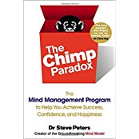The Chimp Paradox: The Mind Management Program to Help You Achieve Success, Confidence, and Happiness Paperback – May 30, 2013 by Dr. Steve Peters (Author).

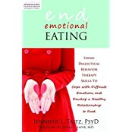End Emotional Eating: Using Dialectical Behavior Therapy Skills to Cope with Difficult Emotions and Develop a Healthy Relationship to Food Paperback – July 1, 2012 by Jennifer Taitz PsyD (Author).

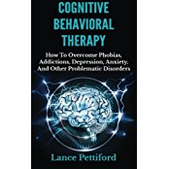Cognitive Behavioral Therapy (CBT): How To Overcome Phobias, Addictions, Depression, Anxiety, And Other Problematic Disorders Paperback – October 16, 2014 by Lance Pettiford (Author).
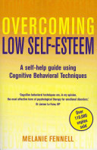 "Melanie Fennell's acclaimed self-help guide will help you to understand your low self-esteem and, armed with this knowledge, break out of the vicious circle of negative self-image, learning the art of self-acceptance and altering our life for the better."

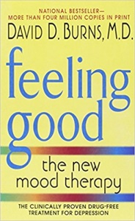The good news is that anxiety, guilt, pessimism, procrastination, low self-esteem, and other "black holes" of depression can be cured without drugs. In Feeling Good, eminent psychiatrist, David D. Burns, M.D., outlines the remarkable, scientifically proven techniques that will immediately lift your spirits and help you develop a positive outlook on life.
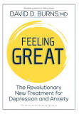 Feeling Great: The Revolutionary New Treatment for Depression and Anxiety
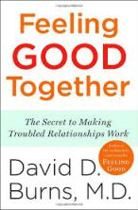 Dr. Burns shows you how to develop more rewarding and loving relationships with the people you care about.
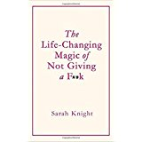 Fed up with pleasing everyone else before you please yourself? Then it's time to stop giving a f**k. This irreverent and practical book explains how to rid yourself of unwanted obligations, shame, and guilt - and give your f**ks instead to people and things that make you happy.
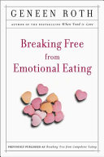Breaking Free From Emotional Eating (Roth, 2003). There is an end to the anguish of emotional eating -- and this book explains how to achieve it.

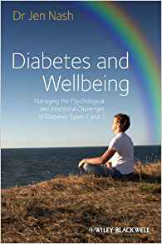Diabetes and Wellbeing: Managing the Psychological and Emotional Challenges of Diabetes Types 1 and 2 (Nash, 2013).

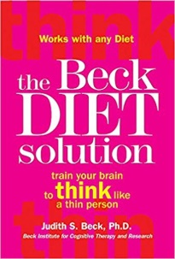The Beck Diet Solution: Train Your Brain to Think Like a Thin Person (Beck, 2009). Dr Beck, one of the foremost authorities in the field of Cognitive Therapy, has created a six-week plan that will help people stick with their diet, lose weight with confidence, and keep weight off for a lifetime. The Beck Diet Solution is designed to build psychological skills that will enable you to: Avoid cheating Cope with hunger and cravings Deal with stress and strong negative emotions without turning to food Motivate yourself to exercise Handle eating out, vacations, and special occasions Eliminate overeating, bingeing, and backsliding

