

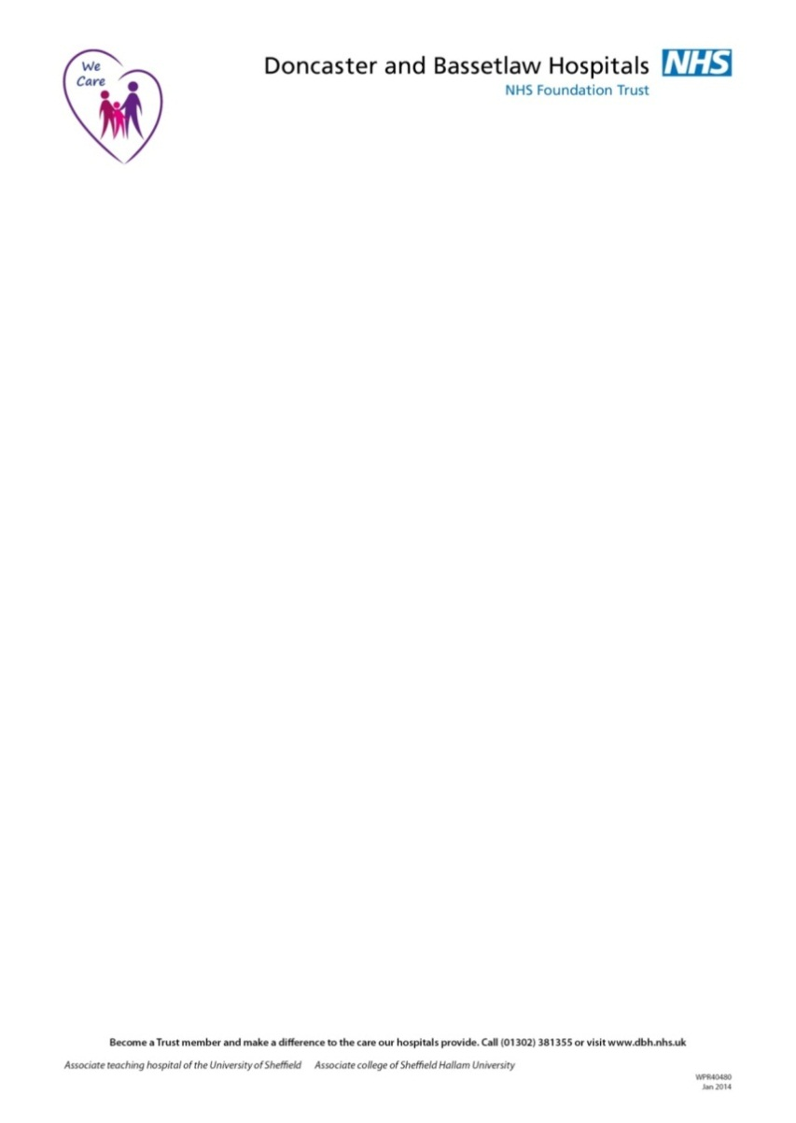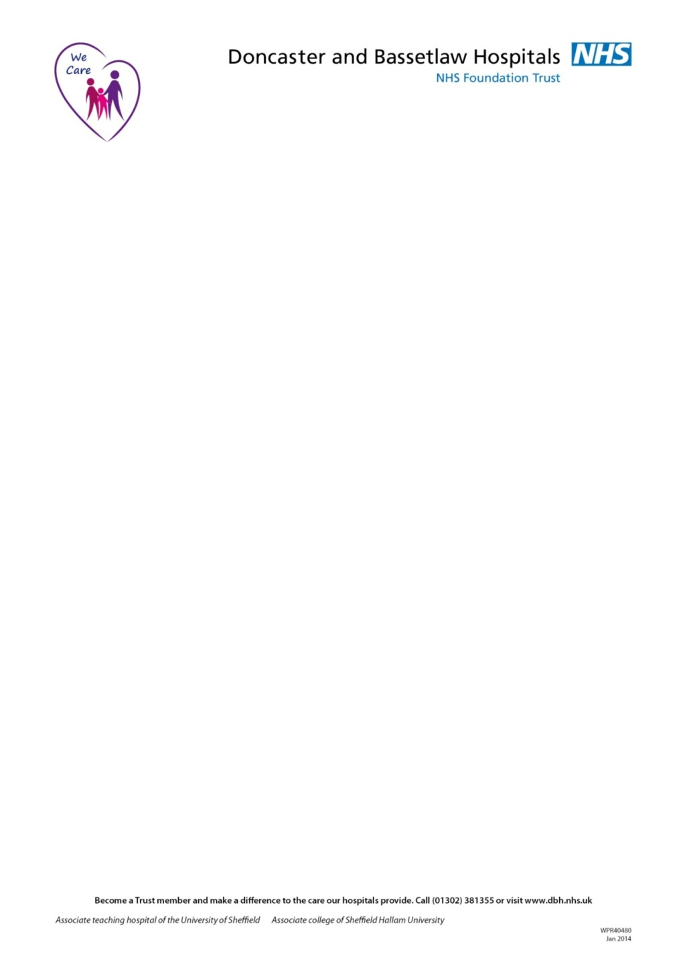





**Knowledge, Library & Information Service**

**Article / Book Request Form**

|  |  |  |  |  |
| --- | --- | --- | --- | --- |
| **Name:**  Click here to enter text. | | | | **Library Card No:**  Click here to enter text. |
| **Department/Address/Postcode** | Click here to enter text. | | | |
| **Job title:** | Click here to enter text. | | | |
| **Organisation:**  (*Delete as appropriate) | click to choose organisation  Other Click here to enter text. (please state)* | | | |
| **E-mail address:** | Click here to enter text. | | | |
| **Contact telephone or**  **bleep no:** | Click here to enter text. | | | |
| **Preferred method of delivery (where possible)** | Collect from library | Internal post | Home address | Secure NHS E-mail(if licence allows) |
| **Copyright declaration to comply with the Copyright, Design and Patents Act 1988:**  1. I have not previously been supplied with a copy of the same material by you or any other librarian.  2. I will not use the copy except for research for a non-commercial purpose or private study and will not supply a copy of it to any other person.  3. To the best of my knowledge no other person with whom I work or study has made or intends to make, at or about the same time as this request, a request for substantially the same material for substantially the same purpose.  4. If this item was delivered by electronic method I will retain only a single paper copy and destroy any electronic copies after printing.  5.I understand that if the declaration is false in a material particular the copy supplied to me by you will be an infringing copy and that I shall be liable for infringement of copyright as if I had made the copy myself.  **Applicant’s signature:** Click here to enter text. **Date:** Click here to enter text.  (This must be the original personal signature of the applicant) | | | | |

***Supply of any request is at the discretion of library staff***

|  |  |  |  |  |  |  |  |  |  |  |  |  |  |  |  |
| --- | --- | --- | --- | --- | --- | --- | --- | --- | --- | --- | --- | --- | --- | --- | --- |
| **Journal title** | | | | | Click here to enter text. | | | | | | | | | | |
| **Author of article or book** | | | | | Click here to enter text. | | | | | | | | | | |
| **Title of article or book** | | | | | Click here to enter text. | | | | | | | | | | |
| **Journal details** | | Year  Click here to enter text. | | | | | Volume  Click here to enter text. | | | Part  Click here to enter text. | | Pages  Click here to enter text. | | ISSN  Click here to enter text. | |
| **Book details** | | Publication date  Click here to enter text. | | | | | Publisher  Click here to enter text. | | | Edition  Click here to enter text. | | ISBN  Click here to enter text. | | | |
| By submitting this form, I understand and agree that any personal data provided above is to be used and processed by DBTH Knowledge, Library & Information Service staff in accordance with the General Data Protection Regulation (GDPR), the Data Protection Act 2018 and local polices for the purposes of the administration and evaluation of the Request Service as detailed in the full Knowledge, Library & Information Service Privacy  Notice online at <https://www.dbth.nhs.uk/services/library-services/forms-guides-publications/> | | | | | | | | | | | | | | | |
| **Staff use only** | | | | | | | | | | | | | | | |
| **Date request received:** | | | | Request No: | | | | Due back: | | | | | Date returned: | | |
| Loc 1 | | | Date sent: | | | | | Date received: | | | | | Shelfmark: | | |
| Loc 2 | | | Date sent: | | | | | Date received: | | | | | Shelfmark: | | |
| Loc 3 | | | Date sent: | | | | | Date received: | | | | | Shelfmark: | | |
| Charges (where applicable) | | Cost: | | | | Date: | | | | | Receipt No: | | Date notified/supplied: | | |
| **Library & Learning Resource Centre**  **Education Centre, Bassetlaw Hospital, S81 0BD Tel: 01909 572917 ext. 572917**  **E-mail:** [**dbth.bas.library@nhs.net**](mailto:dbth.bas.library@nhs.net) | | | | | | | | **Library & Learning Resource Centre**  **Doncaster Royal Infirmary, DN2 5LT**  **Tel: 01302 642894 ext. 642894**  **E-mail:** [**dbth.dri.library@nhs.net**](mailto:dbth.dri.library@nhs.net) | | | | | |