JOB DESCRIPTION

Job Title: Medical Secretary

- WE CARE FOR YOU

We care because:
• We always put the patient first.
• Everyone counts – we treat each other with courtesy, honesty, respect and dignity
• Committed to quality and continuously improving patient experience.
• Always caring and compassionate.
• Responsible and accountable for our actions – taking pride in our work.
• Encouraging and valuing our diverse staff and rewarding ability and innovation
2. JOB IDENTIFICATION

Job Title: Medical Secretary

Grade: Indicative Band 3

Department(s):

Responsible to: Team Leader

Accountable to: General Manager

JD Ref No: (for A4C office use)

3. JOB PURPOSE

The Post holder will provide an effective and efficient support service to clinical teams, ensuring robust systems and processes are in place for overall administrative oversight and management of the patient pathway. This will include achievement of waiting times targets through validation and education, promoting a “Right First Time” culture.
The post holder will be responsible for checking, monitoring and progressing all aspects of the patient pathway taking a cross cutting approach in line with clinical instruction and in accordance with national and local waiting times, liaising directly with the consultant and delegated members of the consultant team, using information reports to assist.
The post holder will have expert knowledge of 18 weeks Referral to Treatment (RTT) rules and ensure application of this knowledge, promoting best practice amongst peers and offering guidance for clinical teams. The post holder will work closely with other members of the clinical admin teams, Team Leader and the Data Quality Team to ensure consistent approaches are applied to RTT validation.
The post holder will have skills in all areas of administrative functions to enable them to support the patient pathway, using Standard Operating Procedures (SOP’s) to ensure that functions of the role are carried out correctly and consistently within given timescales.

4. MAIN DUTIES/RESPONSIBILITIES

- Oversee all aspects of the patient pathway liaising as appropriate with other members of the clinical administration team for timely and accurate system recording, in line with clinical instruction and with national and local waiting time targets.
- Use information reports/Patient Target List (PTL) to perform appropriate checks and co-ordinate next appointments/activities in line with clinical instruction/local/national agreed waiting times, working closely with consultants and delegated members of team to manage capacity effectively.
- Undertake appropriate checks to ensure all clinical outcomes have been recorded correctly and timely on the PAS system, taking corrective action when required via agreed standard operating procedures.
- Ensure all results/correspondence/equipment is made available for clinical activities
- Identify any patterns and trends with incorrect recording/missing data, liaising directly with other members of clinical administration teams to educate and correct to ensure validity of trust information reports/patient pathway status.
- Use knowledge to provide guidance on pathway management to promote awareness amongst colleagues and clinical teams to promote “Right First Time” culture
- Provide consultants with required information to allow informed clinical decisions to be made in line with pathway status/waiting time position
- Bring to immediate attention of the responsible clinician where patient pathway is compromised, escalating to line manager where solution is not found
- Undertake audits upon request from the Team Leader/Line Manager in order to understand identified issues and develop plans to improve.
- Adopt proactive waiting list management approach to ensure best use of capacity, consistent patient service and allow early opportunity to flag capacity issues to Consultant and Team Leader.
- Ensure Inter-Provider Transfers (IPT) are completed/actioned in line with standard operating procedure.
- ‘Top and tail’ any outsourced transcription in line with agreed standards.
- Type clinical correspondence using audio dictation to ensure agreed turnaround times are achieved, escalating to Team Leader where other aspects of work may be compromised
- Monitor clinical typing levels escalating to Team Leader where backlogs are developing
- Monitor, action/co-ordinate in patient waiting list to ensure patients are booked in line with clinical priority and national/local waiting times, liaising directly with clinical teams to ensure efficient use of theatre capacity.
- In line with local arrangements and on clinical instruction, communicate basic clinical information to patients relating to their procedures and treatments, ensuring appropriate distribution of patient information
- Assist with the concerns of patients, primary care and other staff, resolving where possible and discussing with line manager where unable to resolve.
- Management of consultant diaries.
- Assigned named contact for consultant/consultants.
- Act as a primary point of contact for patient pathway queries/issues
- Provide line managers with performance information in line with PTLs, as required
- Under the supervision of the Team Leader/Service Manager, take an active role in the contribution to the appraisal process, conducting return to work meetings following sickness absence and day to day work allocation when required to do so.

Clinical Admin Generic duties/responsibilities

- Adhere to local, national and clinically indicated maximum timeframes including Referral to Treatment (RTT), Cancer, and diagnostics, escalating where capacity does not allow or there are conflicting targets.
- Application of relevant policies/SOPs to ensure consistent services are delivered
- Attend meetings for service development initiatives as required.
- Follow internal escalation processes.
- Attend/complete all mandatory training in accordance with Trust Policy and participate in the Trust’s Annual Appraisal.
- Use of trust developed patient target lists and/or other information reports for consistent facilitation of patient pathway
- Liaise with any relevant member of the Trust or external to the Trust, as appropriate to your role to ensure efficient and timely flow of patient pathway, in line with information governance policy.
- Contribution to achievement of local/national Key Performance Indicators relevant to the role.
- Liaise as appropriate to ensure correct system recording of patient pathway and demographic details in order to prevent data quality issues.
- Be aware of and adhere to the Trust’s Policies, Procedures and Disciplinary rules, and promote awareness amongst peers.
- To participate in training/induction of new staff.
- Be an active team member and undertake any other duties that may be reasonably requested to facilitate the smooth running of the Trust ensuring confidentiality at all times, maintaining good relationships with patients and other members of staff.
- Promote data quality by adhering to best practices and operating standards
- Provide cover as necessary at the request of the Line Manager across the core clinical administration functions, commensurate with level of the role.

Supervisory
- Contribute to the effective work allocation of the Clinical Typists, including assisting with training as and when required.

- Assist in representing the department at relevant Trust meetings with regard to admissions office procedures, i.e. attend trauma meetings

- Assume all administrative roles in the absence of the Team Leader

5. SCOPE AND RANGE
The post holder is appointed to a division and may be assigned to any department to ensure consistent management of workload and consistent cover.

The above indicates the main duties of the post, which may be reviewed in the light of experience and developments within the service. Any review will be undertaken in conjunction with the People and Organisational Development Department.

6. PERSONAL ATTRIBUTES


7. ORGANISATIONAL POSITION
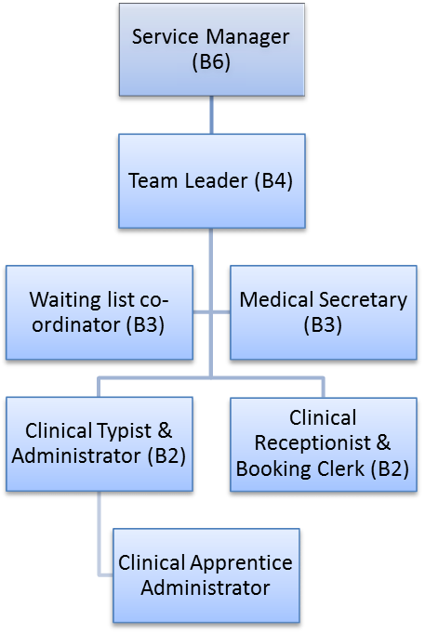

8. JOB DESCRIPTION AGREEMENT

Job Holder’s Signature: Date:

Head of Department Signature: Date:

APPENDIX 1 - SPECIFIC TERMS

- All staff and volunteers working within the trust have a duty to be aware of their own and the organisation’s roles and responsibilities for safeguarding and protecting children and young people, and vulnerable adults. You must be competent to recognise abuse, respond appropriately and contribute to the processes for safeguarding, accessing training and supervision as appropriate to your role. The prevention and control of infection is an integral part of the role of all health care personnel. Staff members, in conjunction with all relevant professionals will contribute to the prevention and control of infection through standard infection control practices and compliance with the Trust’s infection control policies in order to ensure the highest quality of care to patients. If your normal duties are directly or indirectly concerned with patient care you must ensure you receive sufficient training, information and supervision on the measures required to prevent and control risks of infection.

- You must be aware of and adhere to Health and Safety legislation, policies and procedures, to ensure your own safety and that of colleagues, patients, visitors and any other person who may be affected by your actions at work. You are reminded of your duty under the Health & Safety at Work Act 1974 to take reasonable care to avoid injury to yourself and others; to officially report all incidents, accidents and hazards using the Critical Incident Reporting Procedure; to use safety equipment provided for your protection at all times and to co-operate with management in meeting statutory requirements.

- Maintaining confidentiality of information related to individual patients or members of staff is a very important aspect of your work within the Trust. Failure to maintain confidentiality of such information may constitute a serious disciplinary offence. Staff should also bear in mind the importance of sharing essential information with carers and others, with the consent of each patient. There will also be circumstances where critical risk information will need to be shared with partner agencies, subject to guidance and advice available from your manager. You should remember that your duty, to respect the confidentiality of the information to which you have access in the course of your employment with the Trust, continues even when you are no longer an employee.

- This job description is not intended to be a complete list of duties and responsibilities, but indicates the main ones attached to the post. It may be amended at a future time after discussion to take account of changing patterns of service and management.

