NHS England
Blueteq Clinicians
Training Guide

Table of Contents

Logging in to the Blueteq system 3
Searching for an existing patient on the system 4
Adding a new patient to the system 6
Editing patient details on the system 7
Adding a drug request: 8
Stopping drug treatment 10
Viewing an approved request 11
Approval letter 11
Uploading other documents 13
An incomplete/saved request 14
Request (proforma) History - Finding existing or previous requests (proformas) 15
Adding a comment to patient notes 16
Other information 17
Appendix I (remdesivir) ……………………………………………………………………………18

Logging in to the Blueteq system

- Open your web browser and go to the following address:
https://www.blueteq-secure.co.uk/trust/
or
Select Blueteq link via your Trust Intranet/Desktop
- Enter login name: first name (space) last name (not case sensitive)
- Enter password (this is case sensitive)

PATIENT DETAILS

Searching for an existing patient on the system

- This function is in the top right hand of the screen. A patient can be searched on several different items: select “Patient” from the drop down list box.

When in “Patient” field enter in “Find Patient”:
    - Patient initials
    - Surname
    - Surname followed by first name or initial
    - Beginning parts of surname and first name
    - First Name only - you need to put a space in front of the name.
    - Date of Birth in DD/MM/YYYY format

OR
In “Hosp.No” field enter
    - Hospital number
    - Patient’s NHS number

Put whatever you decide to use in the "Find Patient" text box
- To search for a "Blueteq ID", choose "Blueteq ID" from the drop down. Press return or click on “Go”.

- You will be offered a list of patients, click on “Go” on the relevant patient.

- You will be taken to the patient’s “List of Encounters” or notes screen:

Wherever you are you can always return to this screen by clicking on “Notes” and then the “View" menu option

Adding a new patient to the system

- If the patient does not exist on the system.

- Select “Patient “– “Add” from the main menu bar.

The following screen will be displayed:

Select Patient
Add

- Complete the relevant patient information.

- Select the relevant GP practice.

- Save.

Editing patient details on the system

- Find the patient in the normal way.
- Choose the "Patient" and "Edit Patient" menu options,
- Make your changes.

DRUG REQUESTS

Adding a drug request:

- Select “Add Request” from the “Patient” menu bar

- It will ask for confirmation of GP. Please update if needed by using the drop down box
- Select the ‘Form Type’
- Select the ‘drug’
- Select the ‘diagnosis’
- Note - if the incorrect drug or diagnosis selection has been made select “Clear Selection”
- Select the appropriate form needed.

A ‘Request form’ will then be displayed.
The relevant NICE guidelines or NHSE policy can be accessed via the hyperlink at the top of the request form.
Hyperlink to relevant NICE guidelines

Clinical administration staff can fill in a form on behalf of the clinician but can only save the request form, which then needs to be checked by the clinician before submitting

A clinician completing the request form can submit immediately and have instant approval.

- Answer all the questions, complete all the relevant information in line with the NICE guidelines and then either “Save” or “Submit” the Request (see notes above regarding saving and submitting).
- All mandatory questions are annotated with *Required
- All questions are written in the affirmative. If the answer is “No” information will pop up on the screen explaining an alternative to follow. (*Consider if an IFR for is appropriate for this patient. Do not proceed with this application.)

- An approval letter will be auto generated by the system. This can be accessed via the patient’s notes and printed if needed.

Stopping drug treatment

- Go to patient notes screen
- Select “End of Treatment” and complete the screen that appears.

Viewing an approved request
- Once a request has been approved it automatically loads on the patient’s action notes.
- There are 3 entries per request
- 1. The details of the request
- 2. The approval
- 3. The approval letter
- Each request has an I.D. number for easier identification.

Icon to view Approval letter
Icon to view Request form
Icon to edit request

Approval letter

- Search for the patient (as described above) then select the ‘Letter’ icon.

- To be updated when we have letter added

- Click on the letter icon.

- See sample approval letter below.

- This can be printed and given to patient along with the prescription to take to Pharmacy and/or filed in the patient’s notes.

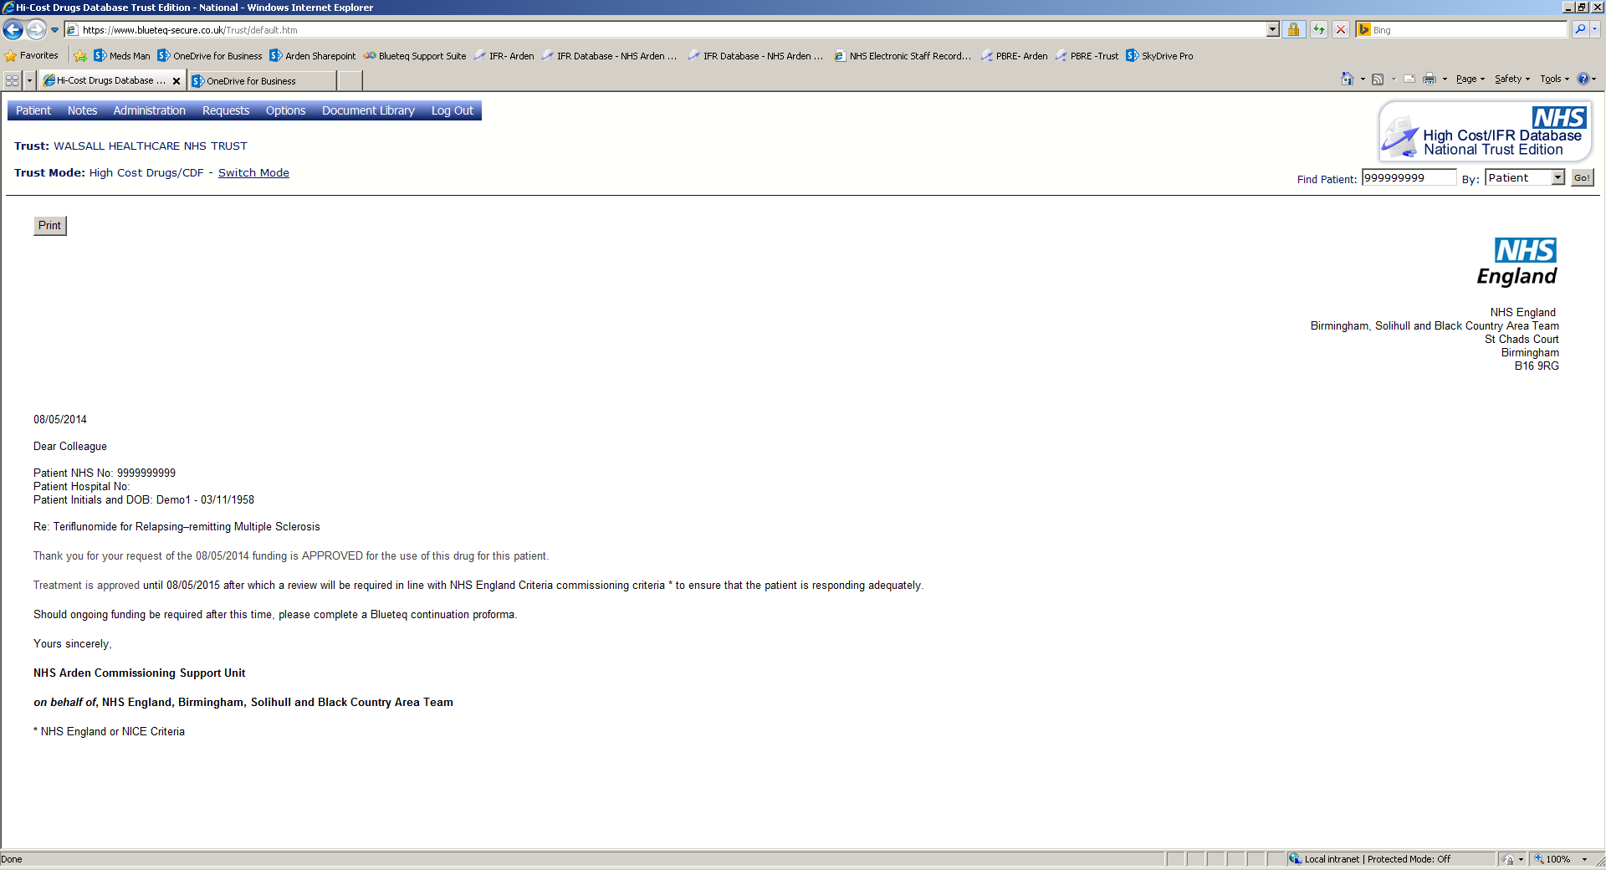
4
2
1
3
- Patient details
- Drug and condition
- Date of request and APPROVAL
- Review date

Uploading other documents
- At the top of the Patient Notes screens, you will notice the following menu options. Other documents (e.g. test results) can be uploaded onto the database by clicking on the ‘Upload Docs’ option.

- The following screen will be presented:

Click on "Browse" to select file; the user will be able to upload a file from their desktop or other folder on their PC or shared folder.
Type a description of the file in the "Enter a Description" field.
Click “Upload”

An incomplete/saved request

- If the form is incomplete or filled in by admin on behalf of the clinician the ‘Request Form’ can be indicated as incomplete and saved using tick box and ‘Save’ button at bottom of the page.
- Incomplete requests can be found by searching for the patient (see finding a patient above), then select the ‘Request Form’ icon. The form will reopen and allow the ‘Request Form’ to be edited and/or checked by clinican and then submitted for approval.

Edit icon

Request (proforma) History - Finding existing or previous requests (proformas)
To view previous requests made by your department
- Select “Administration”-“ Request History”

- Select from the drop down boxes on “Request Type” – “Department” and “Status” the appropriate filtered required for the report.

Select department from the drop down list box
Select the type of request from the drop down list. i.e CDF (Cancer Drugs Fund) or Non -CDF

Select the appropriate request status from the drop down list- Note: default is “Received” status

  - All the relevant requests to the search criteria will display on screen.

Adding a comment to patient notes

- Adding a comment to the patient’s record (e.g. to note a telephone conversation)
Select Comment from the menu bar

- Select the “Comment” menu option.
- Free text in the “Comment” box

Enter comment

- Select “OK”
- The comment will appear on the patient’s notes (see below)

Other information

For Technical system queries (Monday to Friday 8:30 - 5:30) – e.g. Screen errors messages, system errors – please email trust@blueteq.co.uk
Queries may be raised at any time and an automated response will be sent to inform you that it is being dealt with. Blueteq will then email you back once the issue is resolved.
If there is an error with the system you will see an “error” page. This will be automatically reported to Blueteq. Please complete details about the error and enter your email address so that Blueteq can contact you once the issue is resolved.

Queries regarding forms, user logins, system setup (Monday to Friday 9.00am to 5pm)
Please contact : arden.hicostdrugs@nhs.net

For Clinical queries (Monday to Friday 9.00am to 5pm)
Please contact: arden.hicostdrugs@nhs.net
or
01926 353700

If internet connection is down, and information urgently needed from the Blueteq system.
(Monday to Friday 9.00am to 5pm)
Please contact: 01926 353700
or
Email trust@blueteq.co.uk with details of your request

Appendix I – REM03 Remdesivir BT from v1.2
REM03_ver1 – Interim Clinical Commissioning Policy: Remdesivir for patients hospitalised with COVID-19 (adults and children ≥12 years) – reference RPS2008
Patient NHS No: |  | Trust:
Patient Hospital No: |  | Practice Code:
Patient's Initials and DoB: |  | GP Postcode:
Choose Consultant:
Consultant Name: | * | Other Contact Details: | *
Notification Email Address: (@NHS.net account ONLY)
Treatment Start Date:
Please indicate whether patient meets the following criteria: |  |  | Please tick
- I confirm that the patient is an adult, or 12 years old or above and at least 40kg, and is hospitalised with suspected or laboratory confirmed SARS-CoV-2 infection with pneumonia requiring supplemental oxygen. |  |  | Yes No
- I confirm all the following apply:  - The patient’s eGFR is above 30ml/min and they are not receiving renal replacement therapy (note caution is needed in patients with eGFR below 50ml/min  - The patient’s ALT is below 5 times upper limit of normal |  |  | Yes No
- I confirm that the patient will receive remdesivir according to the interim clinical commissioning policy*  * As part of the policy sites are encouraged to submit data through the ISARIC 4C Clinical Characterisation Protocol (CCP) case report forms (CRFs), as coordinated by the COVID-19 Clinical Information Network (CO-CIN) |  |  | Yes No

