Health Passport
Supporting All My Health Needs

Name:...............................................................................................

Date of birth:...................................................................................................

NHS number:....................................................................................................

D number:.................................................................................................
RDaSH leading the way with care

Please read the whole document and ask • me / • my family / • carers
(Circle all relevant)

Name: .................................................................................................

Prefers to be called: ............................................................................

Address: .............................................................................................
.............................................................................................................

Contact Number: .................................. Next of kin: .................................

Emergency Contact details:

GP/ Surgery: ........................................... Tel Number:..............................

Any relevant information: (please circle)

Type 1 or Type 2 Diabetes • Regular Aspirin or blood thinners

(State name of drug)...................................................................................

Attach copy of recent Medicine Administration Record sheet or repeat request

Any known cognitive impairment, learning disability diagnosis, please add below

....................................................................................................................

(Circle all relevant)
• I wear glasses • I wear hearing aid • Any prosthetics

Any history of MRSA, C.Diff or Carbapenem-resistant Enterobacteriaceae (CRE) – any current antibiotic therapy

Vaccine status: COVID .............................. Flu..................................

Others please add .....................................................................................

Allergies: ...................................................................................................

Urgent reasonable adjustments
- ..........................................................................................................

- ..........................................................................................................

- ..........................................................................................................

Brief communication summary:
My first language is.....................................................................................

I speak well or I use …………………………………………to communicate

I can/ cannot read and write

A - Airway
Are there any known airway issues, do they breathe independently?
B - Breathing
Any diagnosed breathing difficulties like asthma, cystic fibrosis, or COPD
C - Circulation
Are there problems with circulation for example hands/ feet are always purple?
D - Disability
What is the person’s diagnoses? How does the person communicate?
What is the person’s
normal mobility?
E - Exposure
We will need to remove clothing, is there anything we should know:

Add anything below that will help with the initial assessment/ paramedics/A&E:

Is there a recent hospital discharge letter: please supply?

Is there a Recommended Summary Plan for Emergency Care and Treatment (ReSPECT) document:

(please tick): ■ YES ■ NO

Is (insert name ……………………………………………..) for resuscitation

(Please tick): ■ YES ■ NO

To be completed at time of request for ambulance or when going to A&E:

S - Situation | What are you worried about most right now?  Any current infection such as Urinary Tract Infections (UTI)
B - Background | Why is this different from other days? How long has it been  going on for?
A - Assessment | Has the person been seen by anyone recently for this  problem?
R - Recommendation | Has this happened before? What worked well?

Is there an Advanced Directive? ■ YES (please attach) ■ NO

Is there a lasting power of attorney for health and welfare?

■ YES, who is named and contact details: ...............................................
…………………………………………………………………………………...
■ NO

Things you must know about me:
Health conditions:

Heart (heart problems): ■ YES ■ NO

Breathing (Respiratory problems): ■ YES ■ NO

Epilepsy: ■ YES ■ NO

Going to the toilet (weeing or pooing).
Please bring catheter passport if you have one

How often do you normally poo and what is it like? – see Bristol Stool Chart on back page

Do you struggle with toilet needs ■ YES ■ NO

Gastric Disorders: ■ YES ■ NO

Eating and drinking issues: ■ YES ■ NO

Medical interventions – how to take my blood, give injections, take temperature, medication (how and who/what helps me), Blood Pressure etc:

How I may present when in hospital or having medical interventions:
Activity | Usual/ baseline | Expected changes when unwell
Going to the toilet or continence aids used

Eating including International Dysphagia Diet Standardisation Initiative (IDDSI) recommendation and utensils needed

Drinking including IDDSI recommendations and ability to use cup/ straw etc.

Moving around, level of support and any equipment required. Do they have bed sides are they likely to walk out of the hospital.

Communication i.e written, verbal, Makaton. How does the person express pain, hunger thirst

Personal care level of independence, how does the person manage in shower, could they strip wash independently. What support do they need to shave or brush teeth.

Sleep, how many pillows, are they hot/cold normally What would be their usual sleep/ wake times

Does the person present with behaviour and what is the person trying to communicate

What level of support will this person receive from the family/ carers when in hospital

How might I cope in hospital?

Please attach any other relevant plans.

Things that will help my stay in hospital
My likes (things I like to talk about)

My dislikes (triggers)

My needs/ wishes

Best approach to health interventions

Discharge planning

I currently live in (explain the property i.e bungalow/ ground floor or house bedroom and bathroom on second floor) is there wheelchair access? Is it supported living care or nursing home?
....................................................................................................................

....................................................................................................................

....................................................................................................................

....................................................................................................................

Equipment I have in place at home (are all staff trained to use equipment?):
....................................................................................................................

....................................................................................................................

....................................................................................................................

Technology I use at home..........................................................................

....................................................................................................................

....................................................................................................................

Response alarm: (please circle) • In house or • local authority

Current care package: i.e 24-hour care or 6 hours per day social care. Who provides care and what limitations to care provided i.e. no medication administration, no healthcare needs, or social care only.

Please state if no support: .........................................................................

....................................................................................................................

....................................................................................................................

....................................................................................................................

Package: who funds this? .........................................................................

Care company/ home manager:.................................................................

Tel number: ..............................................................................................

Information sharing: please talk to family/ carer or nurse/ social worker/ community Learning Disability Team – involve in any best interest meeting:

Person ....................................................................................................

Role................................................ Tel No .............................................

Person ....................................................................................................

Role................................................ Tel No .............................................

Person ....................................................................................................

Role................................................ Tel No .............................................

Plan for me to get back home – do I need including or is it better to tell me when I am leaving.

Consider including Home Care Team and use a social story if circumstances are changing.

Referrals needed: (please circle) • inpatient or • outpatient

- Hospital Occupational Therapy/ Physiotherapy/ Speech and Language Therapy
- Learning Disability Hospital Liaison Nurse
- Integrated Discharge Team
- Independent Mental Capacity Advocates
- Social Worker
- Learning Disability Health Team and/ or Mental Health Team
- District Nurses GP
- Infection Prevention and Control (IPC) Team (Community) if discharged supported living or residential/ nursing care if IPC concerns

Previous hospital admissions:.................................................................

Previous hospital admissions:.................................................................

Reason for admission ..............................................................................

Date ..................................... Where/ which ward.....................................

Basic outcome ..........................................................................................

Previous hospital admissions
Reason for admission | Date | Where/which ward | Basic outcome

Health appointments

Record annual health check, optician, dentist, and health screening

I prefer my appointments to be (please circle):

• morning • afternoon • I don’t mind

I will have support from parents / carers at my appointment

■ YES ■ NO

I would like support from Learning Disability Ambassador or Learning Disability Liaison Nurse

■ YES ■ NO

In my appointment I may need …………………………………….. present

People who help me look after my care

Person ....................................................................................................

Role................................................ Tel No .............................................

Person ....................................................................................................

Role................................................ Tel No .............................................

Person ....................................................................................................

Role................................................ Tel No .............................................

Type of appointment | Date | Where/which ward | Basic outcome

Vaccination History

Vaccine Name | Date Vaccine Given | Batch Number | GP/ Clinic/Other

Bristol Stool Chart – for information
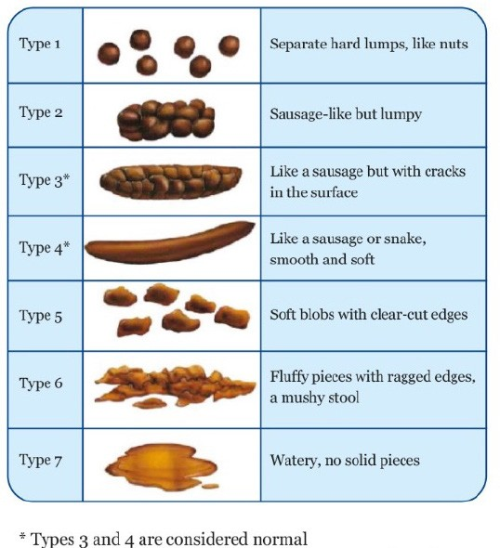

This information is correct at the time of publishing
Last Reviewed: November 2022
DP8827/11.22
We are a smokefree organisation. Please provide a smoke free environment for your healthcare provider
get

