**

**Hand Hygiene**

**This procedural document supersedes: Hand Hygiene - PAT/IC 5 v.8**

**Did you print this document yourself?**

The Trust discourages the retention of hard copies of policies and can only guarantee that the policy on the Trust website is the most up-to-date version. **If, for exceptional reasons, you need to print a policy off, it is only valid for 24 hours.**

|  |  |
| --- | --- |
| Executive Sponsor(s): | Karen Jessop – Director of Nursing, Midwifery and Allied Health Professionals |
| Author/reviewer: (this version) | Sarah Flinders  Infection Prevention & Control Practitioner |
| Date written/revised: | March 2023 |
| Approved by: | Infection Prevention & Control Committee |
| Date of approval: | March 2023 |
| Date issued: | March 2023 |
| Next review date: | March 2026 |
| Target audience: | Trust wide |

**Amendment Form**

|  |  |  |  |
| --- | --- | --- | --- |
| **Version** | **Date**  **Issued** | **Brief Summary of Changes** | **Author** |
| Version 9 | March 2023 | * Updated section 4.D – Changed title to Wash basin, soap and water. Included information for regarding practices for wash basins. * Updated section 4.H – Surgical scrubbing with a nail pick. Updated guidance. * Updated section 4.4, Patient Hand Hygiene. * Updated Section 4.5- Included waste bin for safe disposal of used hand towels. * Updated Section 4.G Antiseptic hand decontamination. * Updated Appendix, added Best practice posters for hand washing with soap, Alcohol Hand rub and surgical scrub. * References updated and monitoring compliance with Tendable. | Sarah Flinders  Infection Prevention & Control Practitioner |
| Version 8 | 23 June 2020 | * Added section/s Patients Lacking Capacity andData Protection * Updated roles and responsibilities on monitoring Compliance section 6. * Updated Appendix, added Hand Hygiene assessment Tool. * References updated | Beverley Bacon  Infection Prevention & Control Team |
| Version 7 | 21 February 2017 | * Section 4 revised. Please read in full, includes sporicidal hand wipes for patients and informing IPC when sinks out of action. | Paula Johnson  Infection Prevention & Control Team |
| Version 6 | 25 June 2014 | * APD format now used. * Incorporated EPIC 3 (2013), guidelines which encompass the best available evidence on hand hygiene. * Amended bare below elbows section to include religious & cultural adornments which may impede effective hand hygiene. * Updated references. | Paula Johnson -  Infection Prevention & Control Team |
| Version 5 | May 2011 | * Section added on The descriptions of points of care given in relation to the “Your 5 moments for hand hygiene” | B Bacon  Lead Nurse Infection Prevention and  Control |
| Version 4 | January 2009 | * Implemented NPSA ALERT recommendations. * Amendment form and contents page added. * Paragraphs numbered. * A section has been added on ‘Bare Below the Elbows’ (item 14, page 8) * Updated references | Infection Prevention and Control |

Contents

**Page No.**

1. Introduction 5

2. Purpose 5

3. Duties and Responsibilities 5

**4.**  **Procedure AND PRODUCT FOR HAND DECONTAMINATION** 6

**4. a** **when to perform Hand Hygiene** 6

**4. B**  **Choice of Hand Cleansing Agents and Types of Hand Decontamination** 7

**4. C** **Social** 7

**4. D**  **Soap and Water** 7

**4. E** **Alcohol Hand Rub (AHR)** 7

**4. F** **Hand wipes** 8

**4. G** **Antiseptic hand decontamination** 8

**4. H**  **Surgical scrub** 8

**4.1** **Hand drying** 8

**4.2** **Hand care** 8

**4.3**  **Bare Below the Elbows (BBE)** 9

**4.4**  **Patient Hand Hygiene** 9

**4.5 Supporting compliance** 10

5. Training/Support 10

6. Monitoring Compliance with the Procedural Document 11

7. Definitions 11

8. Equality Impact Assessment 12

9. ASSOCIATED TRUST PROCEDURAL DOCUMENTS 12

10. data protection 13

11. REFEREnCES 13

Appendix 1 – Your 5 Moments for Hand hygiene 14

APPENDIX 2 – hand hygiene technique 15

Appendix 3 – Alchol Hand rub (ARH) technique 16

Appendix 4 – Hand hygiene ASSESSMENT TOOL 17

**appendix 4 – equality impact assessment - part 1 initial screening** 18

1. Introduction

**Hand Hygiene is considered the single most important factor to reduce the risk of Healthcare Associated Infections**

**Why is hand decontamination crucial to the prevention of HCAI?**

Hand decontamination can protect both the patient/visitor and the healthcare worker, from acquiring micro-organisms which may cause them harm.

Cross-transmission is the transfer of organisms between humans. It can occur directly via hands, or indirectly via an environmental source, such as a commode or wash-bowl. It precedes cross-infection and epidemiological evidence indicates that hand-mediated cross-transmission is a major contributing factor in the current infection threats to hospital in-patients.

**Classification of Hand Flora**

Hands are colonised with two types of micro-organisms:

* **Resident organisms** which lie in the deeper layers of the skin and do not readily cause infection. They are commonly termed normal flora or commensals.
* **Transient organisms** which lie on the top surface of the skin and can be picked up and transferred readily. Hands may be contaminated by direct contact with patients, indirectly by handling equipment or through contact with the general environment. Thorough routine hand washing using liquid/foam soap and water removes approximately 98% of transient micro-organisms. The use of alcohol hand rubs will achieve a similar or better log reduction, when used on clean hands.

2. Purpose

To outline recommendations based on the best available evidence, concerning hand hygiene, which must be employed to reduce the risk of infection to patients, staff and visitors.

3. Duties and Responsibilities

Individual: Each individual member of staff, volunteer or contracted worker within the Trust has a personal responsibility to comply with the Hand Hygiene Policy and reduce the spread of infection.

Managers: It is the responsibility of Divisional managers and senior nurses to ensure compliance with this standard.

Infection Prevention and Control Team (IPCT): It is the responsibility of IPCT to review emerging evidence and national guidance, raise awareness and validate local audit on compliance with policy.

**PATIENTS LACKING CAPACITY**

Sometimes it will be necessary to provide care and treatment to patients who lack the capacity to make decisions related to the content of this policy. In these instances staff must treat the patient in accordance with the Mental Capacity Act 2005 (MCA 2005).

* A person lacking capacity should not be treated in a manner which can be seen as discriminatory.
* Any act done for, or any decision made on behalf of a patient who lacks capacity must be done, or made, in the persons Best Interest* see definitions.
* Further information can be found in the MCA policy, and the Code of Practice, both available on the intranet.

**4. Procedure AND PRODUCT FOR HAND DECONTAMINATION**

**Hand decontamination**

Hands must be decontaminated immediately before each and every episode of direct patient contact/care and after any activity or contact that potentially results in hands becoming contaminated.

**4. a when to perform Hand Hygiene**

**The point of care is the crucial moment for hand hygiene.** It represents the time and place at which there is the highest likelihood of transmission of micro-organisms from the hands of healthcare workers to patients/clients/residents and vice versa.

The World Health Organisation has defined **the 5 Moments for Hand Hygiene**, as the critical times at which Hand Hygiene should occur. **Hands must be decontaminated between caring for different patients or between different care activities for the same patient**. For example, although Hand Hygiene occurred before patient contact (Moment 1) e.g. touching a patients hand, it should also be undertaken before undertaking a clean or aseptic procedure (Moment 3) on that same patient

The 5 Moments can be applied to all care settings. (see appendix 1)

It is also essential to decontaminate hands before and/or after a range of activities e.g.:

• When preparing, handling or consuming food and drinks

• After visiting the toilet

• After handling contaminated waste

• Before entering and leaving isolation rooms

• Before commencing and leaving work

• Before applying and immediately after removing Personal Protective Equipment(PPE) such as aprons & gloves

• Whenever hands are visibly soiled.

**4. B Choice of Hand Cleansing Agents and Types of Hand Decontamination**

*This depends on the circumstances and level of decontamination required.*

There are 4 main types of cleansing agent: soap & water, alcohol based hand rub, hand wipes and antiseptic cleansing agents.

There are 3 methods of hand decontamination: social, antiseptic hand decontamination and surgical scrub technique.

**4. C Social**

Most daily activities require social hand decontamination using either soap & water, alcohol-based hand rub or hand wipes. See below for suitability:

**4. D Soap and Water**

* Sufficient for most routine daily activities, or when hands visibly soiled
* In clinical areas liquid/foam soap should be used and must be stored in well maintained wall mounted dispensers.
* The quality of water in healthcare settings is monitored by the estates department (e.g. pseudomonas and legionella testing).

The correct procedure for routine hand washing – see appendix 2

**4. E Alcohol Hand Rub (AHR)**

* Hands must be visibly clean and have not been in contact with bodily fluids (e.g. urine/faeces).
* Should be rubbed onto all surfaces of the hands (for approximately 30 seconds).
* Not effective with enteric pathogens such as Clostridium Difficile or Noro-virus.
* AHR should be available at the point of care to facilitate hand hygiene.
* Individual toggles of AHR should only be used in areas which have undergone an IPC risk assessment and should not be refilled.
* AHR can be re-applied to achieve further hand decontamination but hands should be washed with soap & water after several consecutive applications.

**4. F Hand wipes**

* Must only be used for patient hand hygiene where self-care is problematic. Please encourage patients to use before meals if bed bound or unable to wash hands at handwashing sink.
* Not to be used by staff to clean their own hands or equipment/ environment.

**4. G Antiseptic hand decontamination**

* Indicated in certain high-risk areas (e.g. DCC, ITU & NNU) **before** undertaking any invasive procedures (e.g. central line insertion). Please contact IPC if risk assessment required.

**4. H Surgical scrub**

Surgical hand decontamination (surgical scrub) is necessary when a greater level of hand and forearm disinfection is required e.g. prior to invasive surgery.

Antiseptic liquids such as povidone-iodine or chlorhexidine 4% scrub should be used. A sterile towel must be used for drying. Please refer to local departmental policy for procedure.

**4.1 Hand drying**

* Wet surfaces transfer micro-organisms more readily than dry ones.
* Paper towels should be used to not only dry the skin but also rub away dead skin cells loosely attached to the surface of the hands.
* Good quality paper towels should be housed in a wall mounted dispenser within easy reach of a sink but beyond splash contamination
* Communal linen towels must **not** be used in clinical areas.
* Hot air dryers maybe used in none clinical areas.

**4.2 Hand care**

* Intact skin is the most effective barrier to micro-organisms.
* Frequent hand washing especially if hands are not properly dried, can cause damage to skin and provide an environment in which organisms can flourish
* Hands must be rinsed and dried thoroughly when soap & water has been used.
* Soap & water hand-washing should be undertaken when there have been consecutive applications of AHR.
* Always wash hands with soap and water after removal of gloves.
* Trust approved aqueous based hand cream should be applied regularly to protect the skin from the drying effects of regular hand decontamination.
* All cuts and abrasions should be covered with a waterproof dressing.
* Contact the Health & Wellbeing Department if skin irritation occurs despite following the above.

**4.3 Bare Below the Elbows (BBE)**

The ‘bare below the elbows’ initiative was introduced as part of the government’s Clean Safe Care Strategy to reduce infection risks by improving the ability to clean the hands effectively.

All staff entering the patient zone (see appendix 1, the 5 Moments) in a clinical area must adopt the ‘bare below the elbows” dress code. Please also see the Policy and Guidance for Standards of Uniform and Dress (CORP/EMP 20).

* Short sleeves (or long sleeves rolled up)
* Ties and Lanyards if worn, must be tucked into the shirt.
* No wrist watch or jewellery to be worn in the patient zone.
* Only one plain ring can be worn
* Fingernails should be kept clean and short (not visible when viewed with palms facing upwards.
* Do not wear artificial nails or nail varnish.
* Any staff who wear their own clothes in the clinical area, must adhere to BBE.
* Staff who wear adornments for cultural/religious reasons should consider if they can be placed on other areas of the body, rather than the hands or wrists. Discuss with IPC if this is problematic.

Effective Leadership and role models can influence positive behaviours with staffs’ compliance of BBE and are key to achieving best practice within the organisation in delivering safe quality of care.

**4.4 Patient Hand Hygiene**

Patients can often feel disempowered when they enter healthcare premises. Results of local audits demonstrate that appropriate patients are not always offered a hand-wipe before meals. They (and their visitors) should be encouraged to discuss hand hygiene with staff. They should also be reminded of their personal responsibility to reduce infection through Hand Hygiene.

Provision of hand hygiene facilities must be tailored to patient need (EPIC 2013). Patients with poor mobility must be offered hand hygiene facilities at the appropriate time (e.g. before eating and after using bedpans/commodes.)

Patient hand-wipes, are available and can be used where necessary for less-ambulant inpatients.

**4.5 Supporting compliance**

Many factors contribute to poor compliance with hand hygiene. To improve compliance and encourage staff to decontaminate their hands regularly and appropriately, managers must ensure that adequate facilities are provided.

These include: -

* Dedicated, accessible hand wash sinks with repairs undertaken as a priority. Please inform IPC of any issues with sinks.
* Appropriate hand-washing facilities must be available in all patient care areas.
* In multi-bed bays, hand wash facilities must be easily accessible from all beds, and sufficient in number to avoid queuing.
* In single rooms, hand wash sinks should be in the room and en-suite if provided.
* Approved liquid/foam soap must be at all sinks.
* Soft absorbent paper hand towels should be available at all hand wash sinks.
* Hand moisturiser should be available via wall mounted dispenser or pump dispenser.
* Alcohol hand rub should be available for use at point of care, e.g. at each bedside.

Consideration should be given to other areas e.g. entrances & notes trolleys.

* All staff in clinical areas must receive training in hand hygiene annually, and complete and annual assessment (see appendix 3).
* Posters promoting hand decontamination should be refreshed regularly and displayed prominently.

5. Training/Support

The training requirements of all staff will be identified through a training needs analysis. Role specific education will be delivered by the service lead or nominated person. Please refer to the Mandatory and Statutory Training Policy (CORP/EMP 29) for details of the training needs analysis, as staff will require different levels of training.

Hand Hygiene competency assessments using the IPC accreditation programme should be undertaken by all clinical ward based staff.

Infection Prevention and Control must be included in individual Annual Development Appraisal and any training needs for IPC addressed.

Posters should also be visible to staff, patients and visitors to raise awareness of the importance of hand hygiene, including hand-washing technique next to sinks.

6. Monitoring Compliance with the Procedural Document

The need for on-going infection control hand hygiene audits is an essential component for the control and prevention of HCAI. The audit tool comprises IPC elements which are measured objectively and based on a nationally agreed set of standards (WHO 5 Moments).

|  |  |  |  |
| --- | --- | --- | --- |
| **Monitoring** | **Who** | **Frequency** | **How Reviewed** |
| Compliance with  policy to negate  cross‐infection. | Ward and departmental Managers are responsible for  ensuring implementation  within their area of best  practice by undertaking  regular audits and  Infection Control Committee (ICC). | According to  risk category  for each ward  or department.  Bi-monthly. | Any deficits identified should be addressed immediately to  facilitate compliance.  Individual wards and department’s compliance will be monitored at the ICC. |
| Hand Hygiene  Competency | Ward and Departmental Managers  (see appendix 3 for Hand Hygiene Assessment Tool) | Annually | The local record and dashboard will be monitored as part of the IPC Accreditation process. |
| Hand Hygiene audits. | Ward and Departmental Managers  Infection Prevention and Control Practitioner | Monthly. | Hand Hygiene audits are submitted to the ward/department dashboard, as part of the IPC Accreditation scheme.  Evidence will be displayed locally in a prominent position. |

7. Definitions

**Alcohol hand-rub (AHR).**An alcohol-containing preparation (liquid, gel or foam) designed for application to the hands to inactivate microorganisms and/or temporarily suppress their growth. This policy refers to AHRs which are compliant with British standards (BS EN1500); standard for efficacy of hygienic hand-rubs using a reference of 60% isopropyl alcohol.

**Antiseptic agent.** An antimicrobial substance that inactivates micro-organisms or inhibits their growth on living tissues. Examples include alcohols, chlorhexidine gluconate (C.H.G), and triclosan.

**Antiseptic hand decontamination***.* Washing hands with soap and water, followed by AHR.

**Aseptic technique -** An aseptic technique ensures that only uncontaminated equipment and fluids come into contact with susceptible body sites. It should be used during any clinical procedure that bypasses the body's natural defences. to minimize the spread of organisms.

**Best Interest -** There is no single definition of Best Interest. Best Interest is determined on an individual basis. All factors relevant to the decision must be taken into account, family and friends should be consulted, and the decision should be in the Best interest of the individual. Please see Section 5 of the Mental Capacity Act code of practice for further information.

**Hand care***.* Actions to reduce the risk of skin damage or irritation.

**Hand cleansing.** Action of performing hand hygiene for the purpose of physically or mechanically removing dirt, organic material and/or microorganisms.

**Hand decontamination -** The use of Alcohol hand-rub or hand-washing to reduce the number of micro-organisms on the hands. In this policy the term is interchangeable with Hand Hygiene.

**Patient zone/Point of care.**  This contains the patient and their immediate surroundings. This typically includes the intact skin of the patient and all inanimate surfaces that are touched by or in direct physical contact with the patient such as the bed rails and tables, bed linen and medical equipment. Point-of-care hand hygiene products should be accessible without Health Care Workers having to leave the patient zone e.g. Alcohol hand-rub (AHR)

**Soap.** Detergents that contain no added antimicrobial agents or may contain these solely as preservatives.

**Surgical Scrub -** Antiseptic hand wash or antiseptic hand rub performed preoperatively by the surgical team to eliminate transient flora and reduce resident skin flora. Such antiseptics often have persistent antimicrobial activity.

8. Equality Impact Assessment

An Equality Impact Assessment (EIA) has been conducted on this procedural document in line with the principles of the Equality Analysis Policy (CORP/EMP 27) and the Fair Treatment For All Policy (CORP/EMP 4).

The purpose of the EIA is to minimise and if possible remove any disproportionate impact on employees on the grounds of race, sex, disability, age, sexual orientation or religious belief. No detriment was identified. See Appendix 3.

9. ASSOCIATED TRUST PROCEDURAL DOCUMENTS

This policy should be read in conjunction with other Trust Policies and protocols for the prevention and control of HCAI in line with the Health and Social Care Act 2014

* Control of Substances Hazardous to Health (COSHH) Guidance – CORP/HSFS 7
* Dress Code and Uniform policy - CORP/EMP 20
* Glove Use Policy (Latex) - CORP/HSFS 13
* Hand Hygiene - PAT/IC 5
* Health and Safety at Work - Medical Surveillance - CORP/HSFS 2
* Isolation Policy - PAT/IC 16
* Medical Devices Management Policy - CORP/PROC 4
* Medical Equipment Training Policy - CORP/RISK 2
* Mental Capacity Act 2005 - Policy and Guidance, including Deprivation of Liberty Safeguards (DoLS) - PAT/PA 19
* Selection and Procurement of Medical Devices Policy - CORP/PROC 3
* Spillage of Blood and other Body Fluids - PAT/IC 18
* Standard Infection Prevention and Control Precautions Policy - PAT/IC 19
* Water Safety Policy - CORP/HSFS 18
* Mobile Communications Policy – CORP/HSFS 16
* Fair Treatment For All Policy - CORP/EMP 4
* Equality Analysis Policy - CORP/EMP 27.

10. data protection

Any personal data processing associated with this policy will be carried out under ‘Current data protection legislation’ as in the Data Protection Act 2018 and the General Data Protection Regulation (GDPR) 2016.

For further information on data processing carried out by the trust, please refer to our Privacy Notices and other information which you can find on the trust website.

11. REFEREnCES

Department of Health. 2012. *The Health and Social Care Act: code of practice for the NHS on the prevention and control of healthcare associated infections.* Department of Health. London.

Loveday H.P, Wilson J.A, Pratt RJ et al. epic3: National Evidence-Based Guidelines for Preventing Healthcare-Associated Infections in NHS Hospitals in England. Journal of Hospital Infection; 2014.

National Institute for Health and Care Excellence.  *NICE Clinical Guideline 2.Infection: prevention and control of healthcare associated infections in primary and community care. (CG139)*. London: National Institute for Health and Care Excellence. 2012.

N.H.S Estates. HBN 00-09. Infection Control in the Built Environment March 2013. London. Department of Health. p47. Available at: [https://www.gov.uk/government/publications/guidance-for](https://www.gov.uk/government/publications/guidance-for9) infection-control-in-the-built-environment (accessed 12/3/14).

Wilson, J. (2019) – Infection Control in Clinical Practice Updated Edition, 3e. London: Bailliere Tindall

Appendix 1 – Your 5 Moments for Hand hygiene

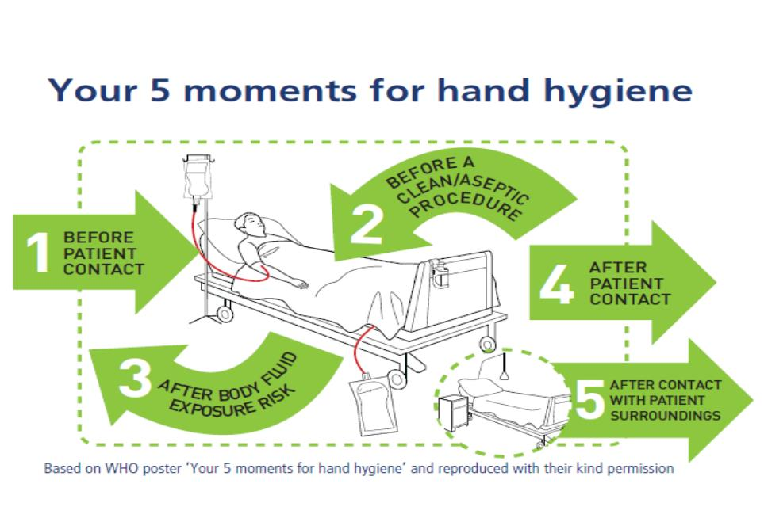

APPENDIX 2 – hand hygiene technique

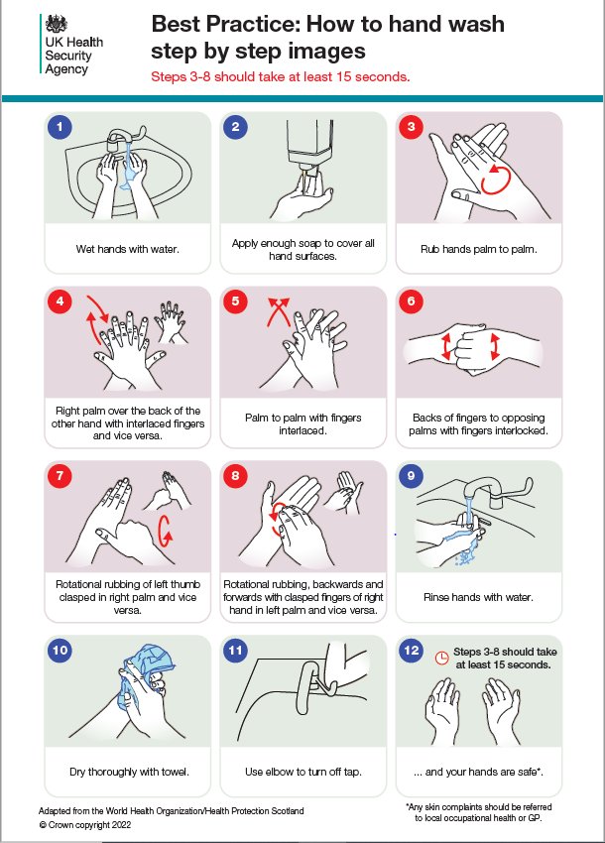

Appendix 3 – Alchol Hand rub (ARH) technique

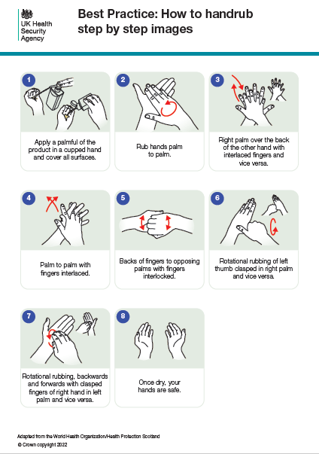

Appendix 4 – Hand hygiene ASSESSMENT TOOL

**HAND HYGIENE ASSESSMENT TOOL**

An assessor who has been trained by a member of the infection prevention and control team, link practitioner or senior nurse should undertake this assessment. The assessment examines the practice of the health care worker (HCW) in the clinical area with adherence to the hand hygiene policy for the trust (PAT IC5). The assessor when conducting duties in their normal clinical environment will observe the member of staff. This assessment should be undertaken on a yearly basis and a record kept by the individual as well as the ward sister. All assessments must be entered onto the OLM database by the ward/dept nominated lead. Failure to enter the data will not result in non compliance status.

If the individual does not achieve a score of 100% in the mandatory sections, they should undergo a period of retraining by the assessor and subsequently re-assessed within one month.

|  |  |  |  |  |
| --- | --- | --- | --- | --- |
| **Name of Assessor: ………………………………………………… Hospital/Ward ……………………………………………….** | | | | |
| **Surname of staff being assessed** | **Forename of staff being assessed** | **Job title/Grade** | **Date of assessment** | **Is this a reassessment?** |
|  |  |  |  | **YES / NO** |

|  |  |  |  |
| --- | --- | --- | --- |
| **(a) CHECK FACILITIES AVAILABLE:** | YES | NO | N/A |
| 1) Is there a hand washing poster available in the clinical area |  |  |  |
| 2) Approved liquid soap present |  |  |  |
| 3) Approved alcohol gel present |  |  |  |
| 4) Approved moisturising cream present |  |  |  |
| 5) Approved paper towels |  |  |  |

|  |  |  |  |
| --- | --- | --- | --- |
|  |  |  |  |
| **(b) *PREPARATION – mandatory:** | *YES | NO | N/A |
| 1) Nails :- Short and clean |  |  |  |
| 2) Nails :- Natural (not false) |  |  |  |
| 3) Nails :- No nail varnish present (answer YES if **no** varnish is present) |  |  |  |
| 4) Fingers have no rings (except x1 plain ring) |  |  |  |
| 5) Not wearing a wrist watch (yes = **no** wrist watch present) |  |  |  |
| 6) Arms are accessible to wash |  |  |  |
|  | *100% required for pass | | |

|  |  |  |  |
| --- | --- | --- | --- |
| **(c) *PROCEDURE** (hand washing) – **mandatory:** | *YES | NO | N/A |
| 1) Are hands wet under warm running water before applying liquid soap? |  |  |  |
| 2) Are hands vigorously rubbed for 15-20 seconds? |  |  |  |
| 3) Is the correct technique used? (Ayliffe et al ‘78 six step approach) |  |  |  |
| 4) Are hands thoroughly rinsed under running water to remove soap residue? |  |  |  |
| 5) Are hands thoroughly dried? |  |  |  |
| 6) Is the tap turned off using elbows or paper towel? |  |  |  |
| 7) Is the waste disposed into a foot operated bin? |  |  |  |
| 8) Is moisturiser used at least 3 times per shift – Ask |  |  |  |
| Note: One hand wash observation only is needed | *100% required for pass | | |

|  |  |  |  |
| --- | --- | --- | --- |
| **(d) *PROCEDURE** (using alcoholic rub) **mandatory:** | *YES | NO | N/A |
| 1) Is alcohol gel applied to visibly clean, dry hands? |  |  |  |
| 2) Is the correct dose applied? |  |  |  |
| 3) Is the alcohol rubbed into all surfaces of the hand? |  |  |  |
| 4) Has the alcohol gel dried before carrying out clinical procedures? |  |  |  |
| Note: One alcoholic rub observation only is needed | *100% required for pass | | |

**Please give a copy of this form to the individual for their CPD file, and keep a copy for the ward file.**

**appendix 4 – equality impact assessment - part 1 initial screening**

|  |  |  |  |  |
| --- | --- | --- | --- | --- |
| **Service/Function/Policy/Project/Strategy** | **Division** | **Assessor (s)** | **New or Existing Service or Policy?** | **Date of Assessment** |
| Hand Hygiene Policy PAT/IC 5 v.8 | Corporate Nursing, IPCT | Beverley Bacon, IPCP | Existing | May 2020 |
| 1. **Who is responsible for this policy?**  Infection Prevention & Control Team Corporate Nursing, IPC | | | | |
| 1. **Describe the purpose of the service / function / policy / project/ strategy?** Who is it intended to benefit? What are the intended outcomes? This policy has been updated using the latest National guidance EPIC3 guidance for the prevention of Healthcare associated infections in NHS hospitals in England. It demonstrates the Trust has a policy for Hand Hygiene which staff should follow, reducing the risk of healthcare associated infections. | | | | |
| 1. **Are there any associated objectives?** Legislation, targets national expectation, standards. The Health and social care Act 2008. EPIC3 guidance. | | | | |
| 1. **What factors contribute or detract from achieving intended outcomes?** Nil. | | | | |
| 1. **Does the policy have an impact in terms of age, race, disability, gender, gender reassignment, sexual orientation, marriage/civil partnership,**   **maternity/pregnancy and religion/belief?** Nil. | | | | |
| * **If yes, please describe current or planned activities to address the impact** [e.g. Monitoring, consultation] | | | | |
| 1. **Is there any scope for new** **measures which would promote equality?** [any actions to be taken N/A | | | | |
| 1. **Are any of the following groups adversely affected by the policy? N/A**  |  |  |  | | --- | --- | --- | | **Protected Characteristics** | **Affected?** | **Impact** | | 1. Age | None | Neutral | | 1. Disability | None | Neutral | | 1. Gender | None | Neutral | | 1. Gender Reassignment | None | Neutral | | 1. Marriage/Civil Partnership | None | Neutral | | 1. Maternity/Pregnancy | None | Neutral | | 1. Race | None | Neutral | | 1. Religion/Belief | None | Neutral | | 1. Sexual Orientation | None | Neutral |  1. **Provide the Equality Rating of the service / function /policy / project / strategy – tick (🗸) outcome box**  |  |  |  |  | | --- | --- | --- | --- | | **Outcome 1 🗸** | **Outcome 2** | **Outcome 3** | **Outcome 4** |   *\*If you have rated the policy as having an outcome of 2, 3 or 4, it is necessary to carry out a detailed assessment and complete a* **Detailed Equality Analysis form in Appendix 4** | | | | |
| **Date for next review:** June 2023 | | | | |
| **Checked by:** Carol Scholey Lead Nurse IPC **Date: May 2020** | | | | |