APD TEMPLATE FOR THE DEVELOPMENT OF A PROCEDURAL DOCUMENT

De-escalation:
Principles and Guidance including Restraint

This procedural document supersedes: PAT/PS 15 v.6 – De-escalation: Principles and Guidance including restraint

This should be read in conjunction with the following policies:
Mental Capacity Act 2005 Policy and Guidance, including Deprivation of Liberty Safeguards (DoLS) – PAT/PA 19
Safeguarding Adults – PAT/PS 8
Safeguarding Children – PAT/PS 10
Aggressive and Violent Behaviour towards Staff – CORP/HSFS 5
Arrangement for the Provision of Care to Individuals who are Violent or Abusive (Age 18 or Over) – PAT/PA 6

Did you print this document yourself?
The Trust discourages the retention of hard copies of policies and can only guarantee that the policy on the Trust website is the most up-to-date version. If, for exceptional reasons, you need to print a policy off, it is only valid for 24 hours.

Executive Sponsor(s): | Karen Jessop, Chief Nurse
Author/reviewer: (this version) | Bethany Cotton, Enhanced Care Matron
Date written/revised: | June 2022
Approved by: | Patient Safety Committee
Date of approval: | July 2023
Date issued: | July 2023
Next review date: | March 2025
Target audience: | Trust-wide

Amendment Form
Version | Date Issued | Brief Summary of Changes | Author
Version 7 | June 2022 | Amendment  - 4.6 legal framework update to include the Mental Health Unit (Use of Force) Act 2018  - 4.11 section added to include pathway for covert medication  - 4.14 after aggressive incident section updated to give more guidance on investigations and debrief  - 4.15 documentation section updated to give more information on completing datix and reference to the Mental Health Unit (Use of Force) Act 2018 | Bethany Cotton
Version 6 | 9 April 2021 | Amendment  - Additional sub-section 4.10 regarding challenging behaviour from patients at risk of falls  - Additional appendix -4 with TIME AND SPACE information  - Additional appendix -5 with 5 For Falls information | Bethany Cotton
Version 5 | 20 Nov 2019 | Amendment  - Additional paragraph added at sub-section 4.9 – Chemical Restraint – regarding IM medication. | Bethany Cotton
Version 4 | 26 April 2019 | - Title Change  - Review and amendments to all sections of policy – please read in full | Bethany Cotton
Version 3 Amended | 1 March 2016 | - Following a national patient safety alert, additional bullet point added to section 4.4 – ‘Decision making and assessment’,  - Patient safety Alert reference added | Deborah Oughtbridge
Version 3 | 29 Sept 2015 | - Title change  - Updated in line with new national guidance and to reflect Trust changes. Changed to provide key principles and general guidance. | Deborah Oughtbridge
Version 2 | July 2013 | - Change of focus of policy to restrictive practice  - Change of title  - Range of minor amendments to update policy following further review and consultation – please read in full | Deborah Oughtbridge
Version 1 | January 2012 | This is a new procedural document, please read in full | Deborah Oughtbridge

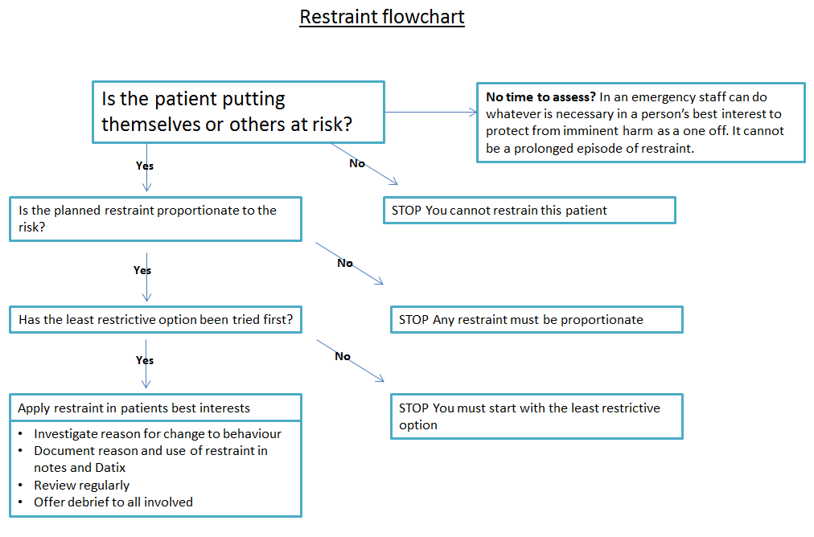

Contents
Page No.

1 Introduction 7
2 PURPOSE 7
3 Duties and Responsibilities 8
4 PROCEDURE 8
4.1 What Causes ‘Challenging Behaviour’ 8
4.2 Patients lacking Capacity 10
4.3 What is De-escalation? 11
4.4 What is Restraint? 12
4.5 Conflict Management and Physical Interventions Training 14
4.6 Vulnerable Patient Groups 16
4.7 Legal Aspects and Frameworks 18
4.8 Procedure and Acting in an Emergency 19
4.9 Risk Assessment 20
4.10 Implementing Physical Interventions 20
4.11 Chemical Restraint 21
4.12 Covert Medication 22
4.13 Escalating challenging behaviour and falls 22
4.14 Calling for Help 23
4.15 After an Aggressive Incident - Investigation, Support and Debrief 24
4.16 Documentation 25
5 Use of Restraint with children and young people 25
5.1 Safeguarding Children 25
5.2 Holding and immobilisation 26
6 Training/support 28
7 Monitoring compliance with the procedural document 28
8 definitions 28
9 Equality impact assessment 29
10 Associated Trust procedural documents 30
11 data protection 30
12 REferences 30
Appendix 1 – De-escalation pathway for over 65’s lacking capacity 32
Appendix 2 – South Yorkshire Police NHS Hospitals Law and Restraint Brief 2018 34
APPENDIX 3 - Principles for the Use of Restraint, Holding and Immobilisation - Children and Young People 38
Appendix 4 – TIME AND SPACE, Yorkshire & the humber clinical network 39
Appendix 5 – Five for falls 40
APPENDIX 6 - Equality Impact assessment part 1 initial screening 41

- Introduction

Doncaster and Bassetlaw Teaching Hospitals NHS Foundation Trust (“the Trust”) is committed to delivering the highest standard of health, safety and welfare to its patients, visitors and employees.

The Trust recognises that a patient’s behaviour can escalate to the point where restrictions or restraint may be needed to protect that person, staff or other patients from significant injury or harm. This policy is written to support staff in de-escalating the patient and providing a supported pathway in the use of restrictions and restraint.

The Trust:-
- Acknowledges there will be occasions when an individual’s behaviour may necessitate the use of restrictions and restraint.
- Recognises that the object of restraint is to maintain the safety of the person being restrained, staff and public present whilst establishing an appropriate degree of control of the situation.
- Pledges that the use of restrictions or restraint will only be considered when all other practical means of managing the situation, such as de-escalation, verbal persuasion, distraction and consideration of medical and physical causes have been unsuccessful in the circumstances.
- Believes that the management of difficult and challenging behaviour is an activity requiring decency, honesty, humanity and respect for the rights of the individual, balanced against the risk of harm to themselves, staff and members of the public.
- Expects that restrictions and restraint used should be proportionate, reasonable and necessary. It will be the least restrictive, which means the shortest time possible and the focus should be on person centred care, and de-escalation.
- Has systems and processes to review all incidents where restraint is deployed, to ensure that the restraint used is reasonable, proportionate and necessary.

In addition, the Trust recognises that there will be circumstances where children and young people require restrictive physical intervention and therapeutic holding, managed in a safe controlled manner, for procedures, treatment or care delivery.

This policy relates to the de-escalation and supported use of restrictions of patients by Trust staff.

- PURPOSE

This policy is intended to provide staff with supportive guidance on de-escalation techniques and understanding the use of restrictive interventions and restraint.
Its aim is to help all involved act appropriately in a safe manner to ensure effective responses in potential or actual difficult situations with a focus on using the least restrictive option available, if de-escalation has not being successful.
It sets out a framework of good practice, ensuring legal, ethical and professional issues have been considered.

The policy covers all staff and persons within the Trust and others who are acting on behalf of the Trust.

This policy applies to patients who are at high risk of requiring restrictive interventions while receiving their care and treatment. This policy also includes a section specifically in relation to guidance on carrying out restrictive physical interventions.

- Duties and Responsibilities

This policy applies to all staff within the Trust who have contact with people who are being, or at risk of being restrained. All staff should be aware of de-escalation and the potential risks to patients who are being restrained.

All staff:-

- Are responsible for having an awareness and understanding of this policy whilst adhering to the guidance provided.
- Need to ensure that all their actions remain within the law and regulatory framework and report any concerns to their manager.
- Have a responsibility to record any incident on the Trust’s Datix incident reporting system
- Advocate the rights of patients who are being restrained
- Need to ensure carers of patients who are being restrained feel supported and involved while the person they care for is in hospital.

- PROCEDURE

4.1 What Causes ‘Challenging Behaviour’

By understanding what causes behaviour it is sometimes possible to avoid using restraint. We are all capable of displaying challenging behaviour when faced with certain situations, it is a reaction to what is happening around us and a way of communicating our emotions when we may not be able to do so verbally.

There are certain groups of people who are much more likely to communicate through their behaviour such as people with dementia, learning disabilities, sensory impairment or mental health problems. But we also need to be aware of other factors. Below are some of the areas that can change a person’s behaviour to be more challenging to us.

Health: Any changes to physical health, pain, medication, disabilities, tiredness, malnutrition and dehydration, dementia, learning disabilities and mental health problems.

Other People: How we react and speak to the person, the relationship we have with them, the language we use.

Environment: Unfamiliar environments in particular will have an impact on behaviour – how accessible is it, comfort levels, signage (lack of), and the layout.

The Person: How they have lived their lives, and what their roles and identity has been through their lives will impact on how they behave.

If a person has difficulty verbally communicating a need then it is highly likely to be expressed through their behaviour and body language. It is important to look beyond their behaviour and attempt to understand the message behind it, and identify the unmet needs.
For example:

- A patient suddenly keeps trying to get out of bed could be a sign of pain
- A patient who keeps walking (often referred to as wandering) around the ward might be looking for something such as the toilet, or a loved one
- A patient lashing out and screaming when staff come near them might be scared and not fully understand what’s happening to them
- A patient’s family tell you that they are not normally confused but currently the patient is very confused, not talking, not eating or drinking and spending lots of time in bed. Sounds like there is a medical reason such as infection, or other condition causing an acute confusion known as delirium
- A patient keeps waking up very early in the morning and gets angry when staff try to encourage them back into bed. Looking at the patient’s life history will give you information on their normal routine, if they usually wake early then allow them to continue this in hospital.

TIME AND SPACE – (see Appendix 4).

A cause of challenging behaviour can be delirium – this is an acute confusional state and is usually the result of the complex interaction of multiple conditions and risk factors. The Yorkshire and the Humber Delirium Clinical Network developed TIME AND SPACE, to provide a reminder to clinicians of the risk factors for Delirium. If you have a patient that has changes to their behaviour and confusion then it is a good tool to go through for possible reversible causes:
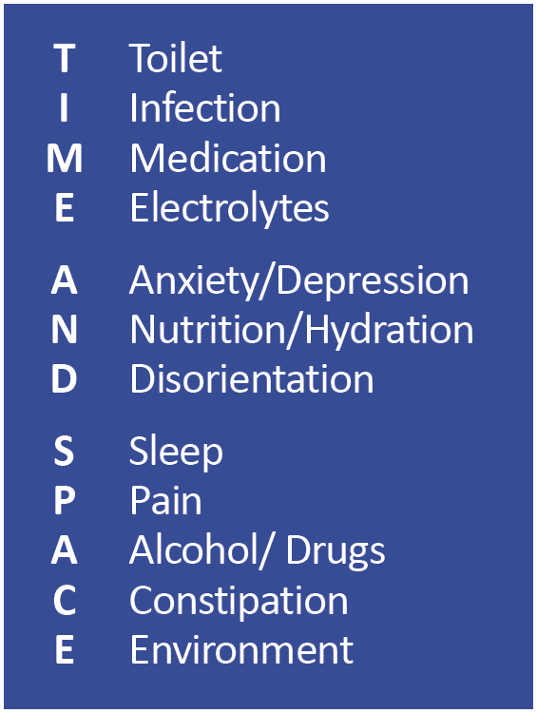

Above all, it is important for us to remember Behaviour = Communication and to ensure we are looking for the reasons behind changed behaviour and not just responding to the behaviour by using restrictive interventions as this will not help the underlying problems, but will often worsen the situation.

4.2 Patients lacking Capacity

Sometimes it will be necessary to provide care and treatment to patients who lack the capacity to make decisions related to the content of this policy. In these instances staff must treat the patient in accordance with the Mental Capacity Act 2005 (MCA 2005)

- A person lacking capacity should not be treated in a manner which can be seen as discriminatory.
- Any act done for, or any decision made on behalf of a patient who lacks capacity must be done, or made, in the persons best interest.
- Further information can be found in the MCA policy, and the Code of Practice, both available on the intranet.
There is no single definition of best interest. Best interest is determined on an individual basis. All factors relevant to the decision must be taken into account, family and friends should be consulted, and the decision should be in the best interest of the individual. Please see S5 of the MCA code of practice for further information.

An Equality Impact Assessment (EIA) has been conducted on this procedural document in line with the principles of the Equality Analysis Policy (CORP/EMP 27) and the Fair Treatment for All Policy (CORP/EMP 4)

The purpose of the EIA is to minimise and if possible remove any disproportionate impact on employees on the grounds of race, sex, disability, age, sexual orientation or religious belief. No detriment was identified.

4.3 What is De-escalation?

On a basic level, de-escalation means ‘to bring down’. The objective of de-escalation is to prevent aggressive and dangerous situations from occurring and so in some situations, reduce the need for restrictive interventions.
De-escalation can take many forms, but to provide safe, effective and fast de-escalation it is important to know who your patient is including normal routines, what makes them sad, what makes them happy, who are the important people in their lives and much more. The easiest way to find all of this information is by asking the family to fill out a ‘This Is Me‘ form or if they have a learning disability ask the family if they have a hospital passport/traffic light system.

Below are some ideas on different ways you could de-escalate a situation. One thing to keep in mind is that sometimes situations can escalate quickly, so it would be sensible to read section 4.9 on chemical restraint for more information

De-escalation techniques

Communication:
Voice | - Introduce yourself  - Gentle and calm tone of voice  - Familiar words  - Use their name regularly  - Acknowledge their feelings  - Never interrupt  - Break down tasks into smaller steps  - One questions at a time  - Ensure understanding  - Avoid invalidation  - Be positive
Body Language | - Face the person  - Calm demeanour  - Eye contact  - Smile  - Go slow  - Plenty of space

Distraction
For more information on de-escalation techniques please refer to the Enhanced Patient Supervision and Engagement Policy

4.4 What is Restraint?

The Framework for Good Practice on the Prevention and Management of the Use of Restraint (last reviewed December 2011) defines restraint as:
“Anything that prevents someone doing something”

The Mental Capacity Act (2005) describes it in more detail:
“Restraint is being used when a person restricts a person’s freedom of movement, whether they are resisting or not”

People can be restrained in different ways in the hospital setting, the different types of restraint can be broadly categorised in the following ways:

Types of restraint

Type | Description | Examples
Physical Intervention | The use of physical contact which is intended to prevent, restrict or subdue movement of any part of the patient's body | Standing in front of a door and preventing someone from passing.  Holding a patients arm whilst blood is taken from the other arm  Holds taught on the Conflict Management Training sessions
Physical/mechanical | The use of a device which is intended to prevent, restrict or subdue movement of any part of the patient’s body, and is for the primary purpose of behavioural control | Bed rails  Tables and chairs used to block someone  Arm cuffs/mittens  Splints  Helmets  Nasogastric bridles  PEG belts  Lap belts  Tipping beds and chairs
Environmental | Using or designing the environment to purposefully limit someone’s ability to move around freely | Locked doors  Steps or stairs  Coded key pads  Narrow doorways  Safe place
Human/ Electronic Surveillance | Electronic systems that monitor or control someone’s movements.  This does not include movement sensors that identify when a patient is at risk of falling | 1:1 care/enhanced care  CCTV  Electronic bracelets that set off an alarm when a person moves somewhere
Verbal/Threats | Making a person feel scared of doing what they want to do or to make someone believe they only have the option to stay in the one care setting | Making someone fear repercussions should they try to resist or leave. Eg. Threatening to withdraw future care should the patient leave the premises
Chemical | The use of medication which is intended to prevent, restrict or subdue movement of any part of the patient's body. This includes the use of rapid tranquillisation (see NICE guideline (NG10) Violence and aggression: short-term management in mental health, health and community settings) | Sedation
Cultural | Using social or cultural pressure to impose limitations on someone’s freedom of movement | Putting someone in bed at an unwanted time  Being deprived of social access, activities or other stimulations

Restraint not sanctioned in DBTH

Certain forms of restraint are not sanctioned under any circumstances because they are either deemed to be disproportionate, abusive or detrimental to the wellbeing of the patient. These are as follows:-

- Positioning furniture to restrict movement.
- Arm cuffs.
- Belt/Lap belt (unless using straps in a person’s own wheelchair which have been fitted for the person).
- Tipping beds and chairs (unless using specialist equipment to support posture recommended by therapy staff and after an assessment).
- Any form of verbal or threat related restraint.
- Any form of cultural restraint.
- Safety sides when used purely to prevent a patient getting out of bed.

Staff who undertake any of the above will be subject to investigation and possible disciplinary proceedings.

Restraint should only be used as a last resort and only when alternative methods of therapeutic behaviour management have failed. It should be least restrictive and the shortest time possible. Any use of restraint should be documented in the patient’s notes and recorded on DATIX.

What is not restraint?

There is sometimes uncertainty with regard to what constitutes restraint. The following actions are not considered to be restraint.
- The use of devices, such as orthopaedic prescribed devices, surgical dressings or bandages, protective helmets
- The physical holding of a patient for the purpose of conducting routine physical examinations or tests or to protect the patient from sliding out of bed, or to permit the patient to participate in activities without the risk of physical harm.
- Bed rails/safety sides when:
- used to prevent the patient from sliding out of bed
- used with trolleys to prevent patients from falling off the trolley
- used with patients who are experiencing involuntary movements
- raised for seizure precautions

4.5 Conflict Management and Physical Interventions Training

Following risk assessments and training needs analysis, training is in place for cohorts of staff in departments that are at extreme and high risk of violence. The training requirements of staff will continually be reviewed by the Trust risk assessment process in clinical areas.

The Trust contracts an external company to provide conflict management training at the two levels; level 1, high risk and level 2, extreme risk.

Level 1 covers de-escalation, communication skills and disengagement – removing yourself from a threatening and dangerous situation.

Level 2 covers the above and also moves onto low level holding. The training covers both non-restrictive holds and restrictive holds:

Non-restrictive | Restrictive
Elbow support | Figure 4 – standing, seated or laying
Straight arm support | Single arm wrap – standing or seated
Bent arm/inside arm support | Double arm wrap – standing or seated

Bed Restraints | Notes
GREEN level - Roofing | - Open Palms  - wrists turn outwards to ensure straight arms  - Maintain space above shoulder and knee/thigh (no direct pressure/ approx. 4 inches)
AMBER level – Roofing but patient escalates to grab staff arms | - Outside arm: hand “cups over the wrist (palm down/thumb to bum), extends down the length of the body (roofing over wrist)  - Inside arm: Open palm, wrists turn outwards to ensure straight arms, Maintain space above shoulder and knee/thigh (no direct pressure/ approx. 4 inches)
RED level – Roofing but with extreme escalation/requirement to ensure no patient movement | - Outside arm: Turns thumb towards self so palm up (inward rotation), flexibility reduced (locked in place), extends down the length of the body  - Inside arm: Open palm, wrists turn outwards to ensure straight arms, Maintain space above shoulder and knee/thigh (no direct pressure/ approx. 4 inches)
RED level with kicking – Roofing but with extreme escalation/requirement to ensure no patient movement and to prevent being kicked | - Outside arm: Turns thumb towards self so palm up (inward rotation), flexibility reduced (locked in place), extends down the length of the body  - Inside arm: Open palm, wrists turn outwards to ensure straight arms, Maintain space above shoulder and knee/thigh (no direct pressure/ approx. 4 inches)  - One staff member swaps over hands to allow outside arm to reach over legs and support on the bed, above the knees and not lying on the patient facing the head of patient for observation and communication (supports self on bed)
Log Roll with sweeping action | - Log roll as Moving & Handling training however due to attempts of patient hitting out, a sweeping motion close to the shoulders is used to minimise risk of being struck  - This then moves down the body to turn the patient over

4.6 Vulnerable Patient Groups

Dementia - Research has shown that the use of restraint in people with dementia is associated with negative outcomes (Evans, Woods, Lambert 2003) and that its use is often accompanied by feelings of shame, loss of dignity, self-respect, loss of identity, anxiety, isolation, and disillusionment (Gastmans 2010).

Evidence shows that patients with dementia in hospital are prone to the loss of function. This is particularly significant when there are prolonged periods of inactivity as the patient might forget how to walk. The use of restraints such as immobilising a person, sedating them or using Posey Mittens for a sustained length of time will increase the risk of their functional loss and increase their confusion.

Based on the empirical evidence and research, it is clear that the use of restraint in patients with dementia is not a desirable option and should only be chosen:
“As a measure of last resort…once all other approaches to manage a situation have been tried and found to have failed” (Hughes 2010)

Restraint is often used in patients with dementia, but not always knowingly. Ward staff unknowingly use psychological, environmental and physical restraints often through telling patients to stay in bed, or stay sat down, and through stopping them leaving the ward if they are going towards the doors.

In its Dementia Guidance, NICE (2018) provides non-pharmacological and pharmacological recommendations on interventions for non-cognitive symptoms and behaviour that challenge in people with dementia.

Learning disabilities – People with learning disabilities may require support with communication. Medical terminology and acronyms are not helpful, use easy to understand simple words and pictures. The Hospital Communication Book is available in all wards and departments.
Diagnostic Overshadowing/Emerson and Baines (2010) was highlighted as "Symptoms of physical ill health are mistakenly attributed to either a mental health or a behaviour problem or as being inherent in the persons learning disabilities".
The pain monitoring tool is also available on all wards and can support the individual to voice their discomfort.

Children – Everyone who comes into contact with children and families has a role to play. Working with children is complex and all staff should be aware of boundaries between themselves as adults and children they come into contact with in a professional manner.
As defined by law:

“A Child is anyone who has not yet reached their 18th birthday”
The Children Act (2004)

As an organisation we have a duty under section 11 of the Children Act 2004 to ensure that we consider the need to safeguard and promote the welfare of children when carrying out our core business.

As professionals we are responsible for ensuring we fulfil our role and responsibilities in a manner consistent with the statutory duties of the employer (HM Government 2018).
If you are concerned about the safety or wellbeing of a child and suspect they may be at risk of harm ensure you follow safeguarding procedures, it is your responsibility to take action.

Mental Health – When in a mental health crisis individuals can become frightened, highly anxious and extremely distressed.

The Care Quality Commission “Count me in” consensus (2011) and the Mental Health Minimum Dataset” state that physical restraint is “the physical restraint of a patient by one or more members of staff in response to aggressive behaviour or resistance to treatment”

Whilst presenting as aggressive, erratic and threatening individuals are often desperate for help and support. Therefore physical restraint for people experiencing high levels of mental/emotional distress physical restraint should be used as a last resort (Bower et al, 2012). It can be disempowering, disabling, fearful and anxiety provoking all of which can result in poor self-worth, poor self-esteem, a loss of identity, sense of self, isolation and disappointment referring to service provision.
When an individual is detained under the Mental Health Act 1983 and an inpatient, staff are allowed to exercise a degree of control over that person, for example preventing the person from leaving or requiring them to leave a public area of the hospital. If necessary force may be required to achieve this, however must be reasonable and proportionate.

The Mental Health Act does not define physical restraint however guidance on restraint and detained patients is in the Mental Health Code of Practice, Chapter 15 Safe and Therapeutic Responses to Disturbed Behaviour, explaining that restraint is a last resort and requires that:

- All hospitals have a policy on the recognition and prevention of disturbed or violent behaviour, risk assessment management incorporating the use of de-escalation techniques, greater observation, physical intervention, rapid tranquilisation and seclusion.
- Physical restraint, rapid tranquillisation, seclusion and observation should only be used where de-escalation has proved insufficient and not as punishment.
- Professionals should not categorise behaviour as disturbed without taking account of the context.
- Idiosyncratic care plans are fundamental to managing disturbed behaviour and problems may be minimised by promoting the therapeutic culture of the ward, whilst identifying and managing problem areas.
- Hospitals’ policies on the management of disturbed behaviour should include clear written policies on the use of restraint and physical interventions, and with all staff aware of the policies which should allow for post-incident review.

4.7 Legal Aspects and Frameworks

The use of restraint in clinical settings is governed by law. Clinicians must ensure that they also refer to their own professional guidance when considering the use of restraint. The main area of legislation regarding the use of restraint and restrictive interventions in the UK is the Mental Capacity Act (2005) – please refer to the Mental Capacity Act 2005 Trust Policy for more information other than the below.

The Mental Capacity Act 2005 (The Act or MCA) received Royal Assent in April 2005, and became law in April 2007. It provides a statutory framework to empower and protect vulnerable people aged 16 years and over, who are not able to make their own decisions. It makes clear who can take decisions, in which situations and how they should go about this. It enables people to plan for a time when they may lose capacity.

Restraint, under the Mental Capacity Act is defined as:

To use – or threaten to use force- to make someone do something that they are resisting, or to restrict a person’s freedom of movement, whether they are resisting or not.

In circumstances where restraint needs to be used, staff restraining a person who lacks capacity will be protected from liability (for example, criminal charges) if certain conditions are met.

The person taking the action must reasonably believe that restraint is necessary to prevent harm to the individual and:

The amount or type of restraint used and the amount of time it lasts must be a proportionate response to the likelihood and seriousness of harm.

Deprivation of Liberty Safeguards (DoLS) became a statutory obligation in April 2009. The introduction of these Safeguards was to protect the most vulnerable people in our society. The Safeguards apply to those adults who lack the capacity to make a decision about their care and/or treatment, where it has been determined that it is in that person’s best interest to remain in hospital. Proportionate restraint may be used to detain patients covered by the DoLS authorisation.

Please see PAT/PA19 Mental Capacity Act 2005 Policy and Guidance, including Deprivation of Liberty Safeguards (DoLS)

The Human Rights Act 1998 – This states that the use of restraint should be justified by a clear rationale. This should explain why other considerations are believed to override the individual’s freedom of actions.

Mental Health Units (Use of Force) Act 2018 – This Act is to reduce the inappropriate use of force and increase the oversight and management of the use of force in mental health units. The Act is applicable to our Trust when patients are detained under the MHA 1983 to one of our hospitals then under the Act, our hospital becomes the Mental Health Unit. This Act promotes a human rights based approach to the use of force, and also states that any use of force has to be documented and reported. For more information on this, please see USE OF FORCE POLICY

4.8 Procedure and Acting in an Emergency

Whilst continuing to assess the reasons why the person may be becoming upset and agitated, and trying to de-escalate the situation, staff need to prepare for the possibility of the person displaying dangerously aggressive behaviour. In these situations please ensure you consider:-

- Moving other patients, relatives and visitors to safety.
- Calling for help (see Section 4.10).
- Visually checking environment for potential weapons the person could use, and checking where your exit is.
- Keep a comfortable distance away from the person, do not invade their space and ensure you are at least out of arms reach.

In an emergency situation where harm to an individual is imminent, staff might be required to restrain a patient prior to undertaking a capacity assessment. This can be done in a person’s best interests as perceived at that time. Situations where this might be appropriate is when a person is about to jump off something, self-harm or harm another person or when a person suddenly tried to pull a line or tube out.

Restraining a person in this situation should be seen as a one off emergency measure, to maintain the person’s safety until an assessment can be made and staff would be protected by common law as long as the response to the risk was proportionate.

It is not acceptable to repeatedly restrain a patient if, for example there are repeated attempts to remove a tracheostomy tube without attempting to undertake a capacity assessment.

4.9 Risk Assessment

When undertaking a risk assessment, staff must weigh up the advantages and disadvantages of the planned action. Many forms of restraint carry a risk and this needs to be considered when making a decision about using it.

A person with capacity may consent to restraint being used. For example a patient might request bed rails. An individual’s choice should be included in a risk assessment and documented in the relevant documentation.

Research studies indicate that the use of restraint carries with it risks to both patients and staff. For example, physical restraint in acute settings increases the risk to staff of direct and indirect injuries, as well as significant negative psychological effects (Evans et al 2002: Huffman, 1998).

Risks for patients include:-

- Patients will fall further if they have to climb over bedrails to get out of bed.
- The risk of developing pressure ulcers, infection, malnutrition and decreased muscle mass is increased in people who are immobilised for long periods.
- Patients who are given sedation are at risk of side effects and have an increased risk of falls.
- All forms of restraint increase the risk and duration of delirium.

4.10 Implementing Physical Interventions

The use of physical interventions is when there is no other option, not doing so would put others at high risk and only used when it is deemed proportionate, and reasonable to the situation. It is a danger to both the patient and the staff involved.

Planning/coordination:
Before implementing physical interventions please ensure that as a team, you are continuing to assess why the person is behaving the way they are. Please also refer to the Mental Capacity section for information on a Best Interests Assessment. Contact Security as soon as possible to assist in physical interventions.

A member of staff should be allocated as the person in charge to coordinate the interventions and that person ideally should be familiar with the patient and have the ability to use clear, direct and uncomplicated communication throughout and have knowledge of the risks associated with physical restraint. The person in charge will also allocate a member of staff to be in charge of supporting and monitoring the patient following the interventions. Security should be involved in the use of restraint but it is always clinically lead.

The person in charge will also ensure that there is access to Basic Life Support equipment within 3 minutes

Remember: You should not, under any circumstances, take any action which would/could endanger either yourself or others. You can only act in accordance with the most recent training you have received.

Any staff using a physical restraint should:-

- Continue to use de-escalation techniques irrespective of the stage of the restraint.
- Ensure that one member of staff assumes control of the restraint process.
- If needing to use physical restraint, apply pressure only to the person’s limbs (pressure must not be applied to the neck, thorax, abdomen, back or pelvic area). The level of pressure (force) applied must be reasonable and necessary and proportionate to the specific situation, and be applied for the minimum possible time.

The person in charge of the physical restraint intervention should:-

- Ensure that the person’s head and neck is appropriately supported.
- Ensure the person’s vital signs are monitored.
- Ensure the staff undertaking the intervention are monitoring and are aware of the risk of asphyxia.
- Always continue to apply de-escalation techniques and deliver rapid tranquilisation (see section 4.10) if felt appropriate.
- Nominate a person to take and record appropriate observations during restraint and for a period of time following the intervention for as long as is clinically necessary.

4.11 Chemical Restraint

Please see Appendix 1 for the De-escalation pathway for over 65’s lacking capacity. Currently there is no Trust pathway for under 65’s, staff are advised to follow national guidance and act within clinical boundaries and competencies.
Following administration of IM medication, a Datix should be completed to ensure the de-escalation process was followed, and that no less restrictive options were available at the time.

4.12 Covert Medication

For patients whose behaviour is escalating and require medication for de-escalation and other physical or mental health conditions it may be necessary to administer covert medication.

Covert medications are medications that are given to a patient without his/her knowledge and often disguised in food or drink. Mentally competent patients can refuse medical treatment including medications even if the refusal can cause harm or accelerate the patient’s death.

Treatment without consent is a breach of Article 8 of the European Convention on Human Rights, the right to respect for private and family life. The exception is treatment for mental health disorder when a patient is detained under the Mental Health Act 1983.
Therefore, covert medications can only be administered in the best interests of a patient who lacks mental capacity and otherwise refuses to take such medications.

Judge Bellamy stated in AG v BMBC & Anor:
- ‘If a person lacks capacity and is unable to understand the risks to their health if they do not take their prescribed medication and the person is refusing to take the medication then it should only be administered covertly in exceptional circumstances.’

The Trust pathway for covert medication is:-

- MDT review.
- Doctor documents lacks capacity and an application made for DOLS.
- Discussion with Next of Kin that they accept the need for covert medication.
- The patient’s doctor and pharmacist review meds and stop non-essential meds / simplify regimen / formulations.
- If alternative formulations don’t help then the medical team documents for covert meds.
- Pharmacist to advise and document on WellSky regarding how to administer.
- Nursing staff to document in care plan / WellSky every time meds given covertly and ensure full dose taken / not spat out.
- Nursing staff to document if any concerns and continue communication with the MDT and Next of Kin.

4.13 Escalating challenging behaviour and falls

Patient with escalating challenging behaviour who has been identified as at risk of falls
- Ensure Five for falls around bedside. (See Appendix 5).
- Consider environment beyond bedside – bags on floor, wires, bins, doors.
- Purple (1:1) interventions where possible (DBTH Enhanced Supervision & Engagement Policy PAT/PS 20).
- Consider TIME AND SPACE and possible reasons why patient is behaving this way (See Appendix 4).
- Safety of other patients and staff:
  - Ensure space from patient, consider moving other patients away from them.
  - Observation from a safe distance, and attempting de-escalation techniques.
- Document that patient’s behaviour is becoming more challenging and managing falls risk will increase alongside this.

4.14 Calling for Help

Remember: You should not, under any circumstances, take any action which would/could endanger either yourself or others. You can only act in accordance with the most recent training you have received.

The above process shows the level of support that should be sought when behaviour is escalating. Ensuring that everyone knows this process and adheres to it will keep staff, patients and visitors safe.

It is very rare that police need to be called to hospital to provide physical restraints and interventions to our patients. Below are some examples requiring a police response that have been adapted from the South Yorkshire Police Mental Health Toolkit (2018) and agreed with South Yorkshire Police

Example 1 – an immediate risk to life and limb
If a patient produces a weapon such as a large knife and threatens to harm staff, patients or visitors, an immediate police response will be necessary.

Example 2 – immediate risk of serious harm
A patient has punched a member of staff and is threatening to harm others. Staff have attempted to de-escalate but any attempt to get near is endangering themselves. The patient is continuing to exhibit aggressive behaviour and there is an immediate risk of serious harm to staff, other patients and visitors. Security have been called but have been unsuccessful in resolving the situation. A police response would be appropriate.

Example 3 – Serious damage to property
A patient in an inpatient unit has caused damage to ward infrastructure including a day room where they have broken chairs, tables, windows and appliances. The floor is covered in debris and the patient continues to cause damage and throw the debris around the room. A police response would be appropriate.

Example 4 – Offensive weapons
A patient has told staff that they have a knife on them for their own protection because they believe that nursing staff will harm them. A police response would be appropriate

Example 5 – Hostages
A patient has closed the door to a room whilst a nurse (for example, or other person) is inside and is shouting, threatening to harm the nurse if anyone enters the room. There is no indication one way or the other as to whether the patient has a weapon and the noise from inside the room suggests that furniture has been piled against the door to block entry. A Police response would be appropriate

4.15 After an Aggressive Incident - Investigation, Support and Debrief

Following any incident where a patients behaviour has required restrictive interventions a debrief needs to take place. This should happen as soon as practicable possible to examine the possible causes to the changed behaviour and the likelihood of it happening again.

The primary objective of a debrief is to reduce the potential of future incidents, improve clinical practice and correct weaknesses through establishing the facts surrounding the incident.

The debrief is intended to be a transparent and objective process and should focus on promoting good communication and a greater understanding of the reasons why we use restrictive interventions. Within the Trust we also have access to the Professional Nurse Advocates who can provided emotional support and restorative supervision following incidents.

Following an incident, an investigation should be conducted with the following questions to guide staff in understanding why this incident occurred.

Question | Notes
What happened? | Time frame, facts, both leading up to and during the incident
What was the patient feeling? | Scared, angry, confused
What did/does the patient need? | if they still have an unmet need, the challenging behaviour will continue
Was the use of restraint appropriate? | Could there have been a less restrictive intervention?
Looking back what could you have done differently? | Was there anything that worsened the situation or anything you felt was missed?
What worked well? | Make sure you discuss the positives
Following the incident is the patient safe and do they understand what has happened and why? | Is it good practice to involve patients in debriefs. This may be done separately to the staff debriefs in some cases depending on the patient but gaining their understanding of the events and providing the patient with sensitive and honest feedback about the reasons for the interventions can aid in lessons learned.
Do you need more advice and support regarding aggressive and violent behaviours? | Get in touch with the Enhanced Care Matron and/or Local Security Management Specialist

4.16 Documentation

A DATIX must be completed to report violence and aggression. If the patient is detained under the MHA 1983 then there are certain demographic information and data that must also be collected under the Mental Health Units (Use of Force) 2018 Act (see USE OF FORCE POLICY for more information).

Ensure a comprehensive record is made of any intervention necessary to manage an individual’s escalating or disturbed behaviour, including full documentation for any clinical decision.

It is important to also document the possible causes of the behaviour and whether or not the causes have gone. If the causes have not gone then it is highly likely that the behaviour will continue. To aid with this, use TIME AND SPACE for possible causes of delirium and changed behaviour, and also ensure the daily Supervision and Engagement assessment and the Enhanced Care Plan are both completed.

- Use of Restraint with children and young people

5.1 Safeguarding Children

The physical restraint or barriers which prevent the child leaving, harming themselves, or causing serious damage to property (previously known as ‘containing’) are also included in the term restrictive physical intervention.

The restraint of children within health care settings may be required to prevent significant and greater harm to the child themselves, practitioners or others. For example in situations where the use of de-escalation techniques have been unsuccessful for children/young people under the influence of drugs or alcohol and who are violent and aggressive. If restrictive physical interventions are required the degree of force should be confined to that necessary to hold the child or young person whilst minimising injury to all involved.

The Children Act (1989) stresses the importance of preventing children from what it terms ‘significant harm’ and, as the child’s closest advocate, the family has a major part to play in decisions affecting the child. In all but the very youngest children, obtain the child’s consent (Department of Health, 2001) or expressed agreement for any situation which is not a real emergency, seek the parent/carer’s consent, or the consent of an independent advocate to make an agreement beforehand with parents/ guardians and the child about what methods will be used, when they will be used and for how long. This agreement should be clearly documented in the plan of care and any event fully documented. Ensure parental presence and involvement - if they wish to be present and involved. Parents/ guardians should not be made to feel guilty if they do not wish to be present during procedures. Nurses should explain parents’ roles in supporting their child, and provide support for them during and after the procedure.

Absconding
There are times when a sick child/young person may attempt to leave.
Decisions made by staff should be made according to the individual circumstances and by considering the child or young person’s best interest. In such situations reasonable measures need to be taken to contain and prevent them from leaving. In all situations the safety and well-being of all other patients and staff must also be considered. If you consider the child to be in immediate danger contact the police on 999. If the child is not in immediate danger but at risk of significant harm follow safeguarding procedures and/or The Missing Person Policy.

Please read the Safeguarding Children’s Policy (PAT/PS 10) for more information.

5.2 Holding and immobilisation

Restrictive physical intervention and therapeutic holding of children and young people within the healthcare setting may be required to prevent significant and greater harm to the child/young person themselves, practitioners or others. If restraint is required, the degree of force should be confined to that necessary to hold the child or young person whilst minimising injury to all involved.

Techniques such as relaxation and distraction, together with pharmacological strategies such as the use of local anaesthetic cream and analgesia should be used.

Clinical holding may be required for:-

• venepuncture
• cannulation
• lumbar puncture
- insertion of naso-gastric tube
• insertion of urinary catheter
• plastering
• administration of medication
• medical examination
• recording observations
• application of splints for treatments
• radiographic examinations

This list is not exhaustive.

The following should always be considered:-

• preparation play
• distraction
• other alternative therapies
- assistance of other professionals

The use of holding
There are occasions when control needs to be exercised over a child but the force of physical restraint is not necessary. This can be achieved through the procedure of holding. This is a controlled technique that can be used for a variety of reasons such as:

- helping children, with their permission, to manage a painful procedure quickly and effectively
- diverting a child from destructive or disruptive behaviour by being led away by the hand, arm or by means of an arm around the shoulder
- separating, by guiding away and holding with little or no force, a child engaged in an argument or fight which in itself is not likely to cause serious harm but is nonetheless disruptive and detrimental to the well-being of others.

Collaborative preparation and planning involving healthcare professionals, the child and their parent’s/carers is essential when a child requires holding for a clinical procedure. Due consideration should be given for the mature child, and to children who are judged to be able to consent to treatment.

Effective preparation, the use of local anaesthesia, sedation and analgesia together with distraction techniques successfully reduce the need for undue force in the use of proactive immobilisation (e.g. holding a child’s arm to take blood or administer an injection to prevent withdrawal and subsequent unnecessary pain to the child). However, ‘therapeutic holding’ without the child’s consent or assent may need to be undertaken against the child’s wishes in order to perform an emergency or urgent intervention in a safe and controlled manner (e.g. a lumbar puncture).

Good preparation for procedures may prevent the need for holding.

If staff are aware in advance that they may have to hold a child for a procedure or therapeutic intervention (i.e. to pass a naso-gastric tube or take blood), this should form part of the care plan and the consent of a person with parental responsibility for the child should be sought.

Discuss and agree on the position to be maintained during the intervention period.

Principles are set out in Appendix 3.

- Training/support

Please note: The training requirements of staff will be identified through a learning needs analysis (LNA). Role specific education will be co-ordinated/ delivered by the topic lead. Alternatively, training may be accessed via an approved e-learning platform where available.

- Monitoring compliance with the procedural document

It is the responsibility of the Division Management Teams to put systems and processes in place to achieve the above and monitor staff awareness and understanding and compliance with this policy. This should include:-

- Roles and responsibilities
- Risk assessment
- Documentation
- Incident figures and review of any incidents recorded through Datix

What is being Monitored | Who will carry out the Monitoring | How often | How Reviewed/  Where Reported to
Adverse incidents reported on Datix | Enhanced Care Matron | On an annual basis or more frequently if issues identified | Division Governance Group
Policy Compliance | Division Management Teams | Annual Basis | Division Governance Group
Incidents where there is a safeguarding element | Safeguarding Team | Annual overview plus individual incident reviews | Strategic Safeguarding People Board

- definitions

Best interests | Health professionals must act in your best interests before taking certain steps that affect your care and treatment.  The Mental Capacity Act has a best interests checklist, which outlines what health professionals need to consider before taking an action or decision for you while you lack capacity.
De-escalation | De-escalation means to bring down, to calm and lessen the escalation of a situation.
Delirium | An acutely disturbed state of mind characterized by restlessness, illusions, and incoherence, occurring in intoxication, fever, and other disorders
Dementia | Dementia is a syndrome – usually of a chronic or progressive nature – in which there is deterioration in cognitive function (i.e. the ability to process thought) beyond what might be expected from normal ageing. It affects memory, thinking, orientation, comprehension, calculation, learning capacity, language, and judgement. Consciousness is not affected. The impairment in cognitive function is commonly accompanied, and occasionally preceded, by deterioration in emotional control, social behaviour, or motivation.
Deprivation of Liberty | A deprivation of liberty is where your liberty is taken away from you - that is, you are not free to leave and under continuous supervision and control. The Mental Capacity Act says that the law allows this only in very specific situations.  This may happen to you if you need to go into a care home or hospital to get care or treatment, but you don't have the capacity to make decisions about this yourself
Mental Capacity | The ability to understand information and make decisions about your life. Sometimes it can also mean the ability to communicate decisions about your life. Assessment of capacity is done one decision at a time, it is not appropriate for a blank statement of ‘lacks capacity’ – it needs to be specific to a decision.
Restraint | Something that restricts freedom or prevents someone from doing something
Restrictive Interventions | An intervention that is used to restrict the rights or freedom of movement of a person including chemical restraint, mechanical, restraint, and seclusion among others
Safeguarding | To protect the health, well-being and human rights of individuals, which allow people — especially children, young people and vulnerable adults — to live free from abuse, harm and neglect
This is Me | This is me is a simple form for anyone receiving professional care who is living with dementia or is experiencing delirium or other communication difficulties.

- Equality impact assessment

The Trust aims to design and implement services, policies and measures that meet the diverse needs of our service, population and workforce, ensuring that none are disadvantaged over others. Our objectives and responsibilities relating to equality and diversity are outlined within our equality schemes. When considering the needs and assessing the impact of a procedural document any discriminatory factors must be identified.

An Equality Impact Assessment (EIA) has been conducted on this procedural document in line with the principles of the Equality Analysis Policy (CORP/EMP 27) and the Fair Treatment for All Policy (CORP/EMP 4).

The purpose of the EIA is to minimise and if possible remove any disproportionate impact on employees on the grounds of race, sex, disability, age, sexual orientation or religious belief. No detriment was identified. (See Appendix 6).

- Associated Trust procedural documents

Mental Capacity Act 2005 Policy and Guidance, including Deprivation of Liberty Safeguards (DoLS) – PAT/PA 19
Safeguarding Adults – PAT/PS 8
Safeguarding Children – PAT/PS 10
Aggressive and Violent Behaviour towards Staff – CORP/HSFS 5
Arrangement for the Provision of Care to Individuals who are Violent or Abusive (Age 18 or Over) – PAT/PA 6
Privacy and Dignity Policy – PAT/PA 28
Fair Treatment for All Policy – CORP/EMP 4
Equality Analysis Policy – CORP/PAT 27
Enhanced Patient Supervision and Engagement Policy - PAT/PS 20
USE OF FORCE ACT

11 data protection

Any personal data processing associated with this policy will be carried out under ‘Current data protection legislation’ as in the Data Protection Act 2018 and the UK General Data Protection Regulation (GDPR) 2021.

For further information on data processing carried out by the trust, please refer to our Privacy Notices and other information which you can find on the trust website: https://www.dbth.nhs.uk/about-us/our-publications/information-governance/

12 REferences

- Bowers L, Van Der Merwe M Paterson B, Stewart D. (2012) Manual restraint and the shows of force: the city 128 study. International Journal of Mental Health Nursing, 21, 20-20
- Care Quality Commission, Essential Standards (2011)
- Care Quality Commission Professional Advice: The administration of Medicines in care homes (2010)
- Counsel and Care (2002) Showing Restraint: Challenging the Use of Restraint in Care Homes. London Counsel and Care
- Department of Health Code of Practice: Mental Health Act 1983 (2008 revised) Department of Health
- Department of Health/Skills for Health/Skills for Care (2014). A Positive and proactive workforce: a guide to workforce development for commissioners and employers seeking to minimise the use of restrictive practices in social care and health.
- Department of Health (2001) Seeking consent: working with older people. London TSO
- Department of Health (2002) Listening, Hearing and Responding. London TSO
- Department of Health (2005) The Mental Capacity Act 2005.
- Department of Health (2014) Positive and Proactive Care: Reducing the need for restrictive intervention
- Department of Health (2009) Deprivation of Liberty Code of Practice
- Duff L, Gray R & Bristow F (1996) The use of control and restraint techniques in acute psychiatric units Psychiatric Care, 3(6), 230-234
- Emmerson E Baines S (2010) Improving Health and Lives: Learning Disability Observatory https:/www.improvinghealthandlives.org.uk/uploads/doc/vid_7479_
- Evans D, Wood J, Lambert L (2003) Patient injury and physical devices. A Systematic review. Journal of Advanced Nursing 41, 3, 274-282
- Gallinagh et al (2001) Perceptions of older people who have experienced physical restraint. British Journal of Nursing 10. 13, 852-859
- Gallinagh R (2002) The use of physical restraints as a safety measure in the care of older people in four rehabilitation wards. Findings from an explanatory study. International Journal of Nursing Studies 39.2, 147-156
- HM Government (2004) The Children Act. HMG, London
- HM Government (2018) Working Together To Safeguard Children. HMG, London
- Hughes R (ed) (2010) Rights, Risks and Restraint Free Care for Older People. London Jessica Kingsley Pub
- Human Rights Act (1998)
- Mental Health Unit (Use of Force) Act (2018)
- NICE (2005) CG 25 Violence: The Short term management of disturbed/violent behavioural in in-patient psychiatric settings and emergency departments London NICE
- Nursing and Midwifery Council (2008) Code, Standards of Conduct, performance and ethics for nurses and midwives London
- Royal College of Nursing (2008) “Let’s talk about restraint” Rights, risks and responsibilities
- SCIE At a glance 16: Managing Risk, minimising restraint (2009)
- [2016] EWCOP 37 http://www.bailii.org/ew/cases/EWCOP/2016/37.html
- South Yorkshire Police Mental Health Toolkit 2018

Appendix 1 – De-escalation pathway for over 65’s lacking capacity
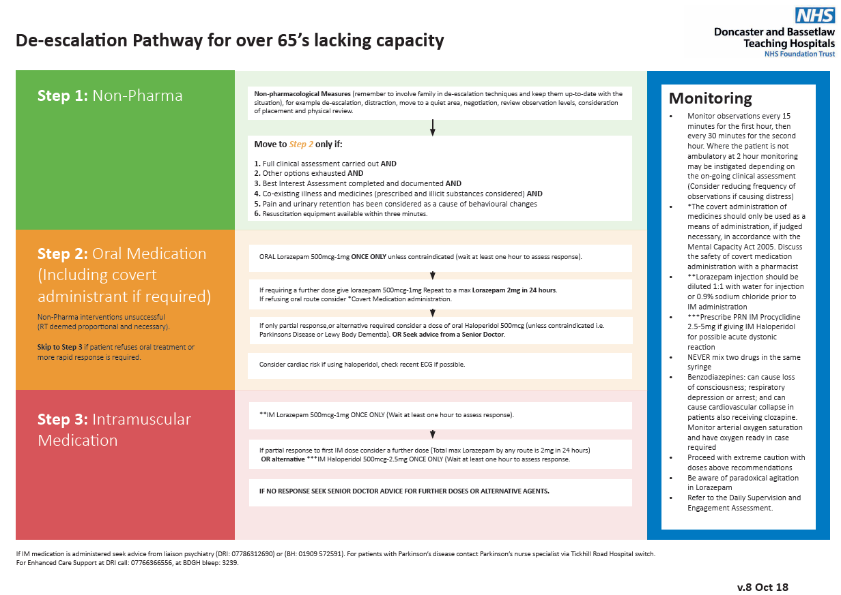
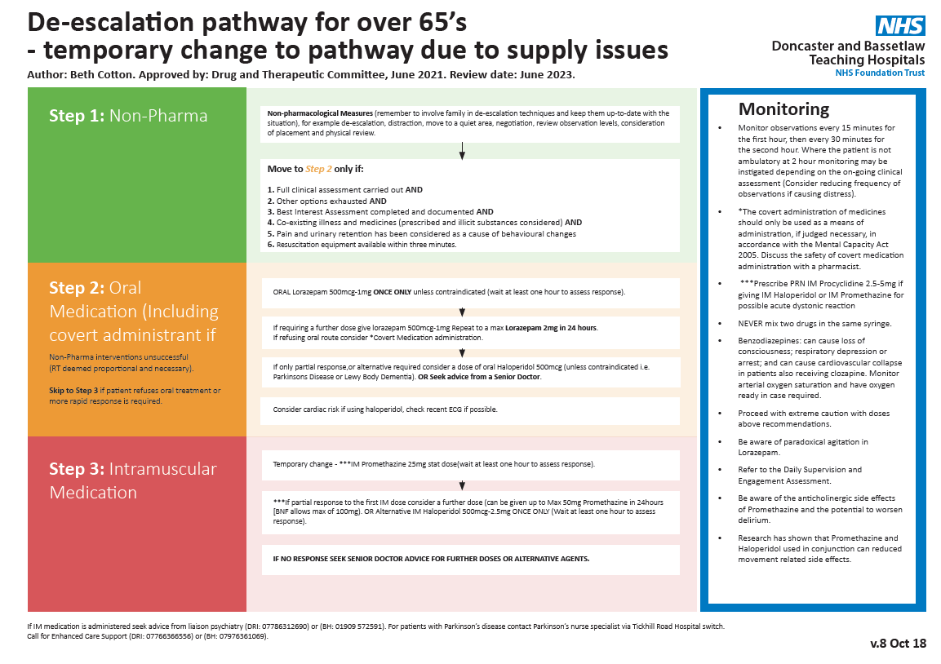

Appendix 2 – South Yorkshire Police NHS Hospitals Law and Restraint Brief 2018

The Law and the Use of Restraint in NHS Hospitals

This brief has been drafted as part of the work of the countywide SYP/NHS Hospital Strategic Demand Reduction Group. Its purpose is to provide clarity and confirm for health care professionals and hospital security staff what they can do legally in relation to the use of restraint.

The brief reflects the guidance in the national Memorandum of Understanding on the Use of Restraint and includes the following content:

- Common Law - Doctrine of Necessity and Breach of the Peace.
- S3 Criminal Law Act 1967
- Mental Capacity Act 2005 – Section 5 & 6
- S119 Criminal Justice and Immigration Act 2008
- Mental Health Act 1983 – Section 5 & 19
- Health & Safety at Work Act 1974
- Management of Health & Safety at Work Regulations 1999
- Human Rights Act 1998

Health care professionals and security staff have available to them statutory and common law powers to detain and/or restrain patients to prevent them from harming themselves or others, to prevent crime and to prevent a breach of the peace. These powers mirror the powers of Police under the common law and under section 3 of the Criminal Law Act 1967.
It will be a matter of risk assessment, competence and degree as to whether any intervention should be undertaken by health care professionals and/or security staff under these provisions.

Common Law
Common Law is based on the precedents established by the courts and is not set against the background of Acts of Parliament.

Doctrine of Necessity
Baroness Hale said in the Court of Appeal in 2003 that “the common law doctrine of necessity … has two aspects. There is a general power to take such steps as is reasonably necessary and proportionate to protect others and from the immediate risk of significant harm. This applies whether or not the patient lacks capacity to make decision for himself …” (Munjaz v Mersey Care NHS Trust and S v Airedale NHS Trust (2003) EWCA Civ 1036, at para. 46).

Breach of the Peace
Police have no power to prevent a Breach of the Peace until one is imminent. It would not be lawful for police to restrain a patient on the basis that they might be violent if not restrained, whereas this is core business for health trusts, who will manage such risk by the use of trained staff.

Breach of the Peace was defined in R v Howell in 1981 as follows:

'A Breach of the Peace is committed whenever harm is done, or is likely to be done to a person, or, in his presence to his property, or, whenever a person is in fear of being harmed through an assault, affray, riot or other disturbance.'

The key characteristic of Breach of the Peace is the use or threat of unlawful violence and should not ordinarily be interpreted as applying to a patient who is presenting management problems in a health environment, in the presence of health professionals and/or health staff. Therefore, the use of Breach of the Peace, within a hospital setting should always be the exception, rather than the rule.

S3 Criminal Law Act 1967
A person may use such force as is reasonable in the circumstances in the prevention of crime, or in effecting or assisting in the lawful arrest of offenders or suspected offenders or of persons unlawfully at large. This is part of the law of self-defence and the defence of others and may be relied upon by anyone.

Other Legal Provisions:

Mental Capacity Act 2005
Where a person thought to be suffering from an impairment or disturbance of the mind or brain lacks capacity concerning a particular decision, another person may do the least restrictive thing in their best interests. Section 5 of the Act will provide a defence to that individual from legal liabilities that would otherwise occur as long as they have taken steps in accordance with the Act to assess capacity and acted in accordance with the general principles of the Act.

Where an action extends to restraint of a person who lacks capacity, by the threatened or actual use of force, this may only be justified under section 6 of the Act where the intended restraint is proportionate both to the risk of harm and to the likelihood of that harm. If restraint extends to such a degree that it amounts to an urgent deprivation of liberty, it may only occur subject to the criteria in section 4B of the Act which requires that action to be life-sustaining intervention or a vital act to prevent a serious deterioration in that persons condition.

Section 120 of the Criminal Justice and Immigration Act 2008

Power to remove a person causing nuisance or disturbance to an NHS staff member on NHS premises. If an “authorised officer” (defined as NHS staff member) reasonably suspects that a person is committing or has committed an offence under s119 of this act the authorised officer may:-

- remove the person from the NHS premises concerned, or
- authorise an appropriate NHS staff member to do so eg. security staff.

The offence under s.119 is only committed if the person causing the nuisance or disturbance has been asked to leave and has refused. The power will not apply where the person to be removed requires medical advice, treatment or care for himself or herself, or the removal of the person would endanger the person's physical or mental health

Any person removing another person from NHS premises under this section may use reasonable force (if necessary).

Mental Health Act 1983
Section 5 – Holding Powers. Whenever a patient is admitted to hospital as an inpatient, the Act affords legal authorities to all doctors and to any ‘prescribed nurses’ (registered mental health or learning disabilities nurse) to ‘hold’ a patient in their care if they suspect the patient has a mental disorder and may come to harm if they leave the hospital.

Doctors may ‘hold’ a patient under S5(2) for assessment under the Mental Health Act for up to 24 hours. Prescribed nurses may detain under S5(4) if the relevant criteria are met and this authority will last for six hours or until either a doctor decides whether to hold the patient under S5(2), as above, or until an Mental Health Act assessment determines whether or not to detain under S2 or S3 of the Act.

The holding powers apply to patients who are inpatients in hospital, which means that these authorities cannot be used for people who attend outpatient clinics or those in Accident & Emergency departments. A&E patients are not admitted as inpatients for the purposes of the Mental Health Act. If an outpatient or A&E patient who had attended for treatment were then admitted to a ward for further care, S5 holding powers come into effect from the point of admission.

When a person is ‘sectioned’, they can be sectioned to a non-psychiatric unit if there are other medical issues in play and a patient’s Mental Health Act detention can then be transferred, under S19, to a psychiatric unit once medical priorities are sorted.

Mental Health Act 1983
Where a patient is detained in hospital under the main provisions of either Part II or Part III MHA, they are liable to treatment decisions to be taken without their consent, under Part IV of the Act. This covers various circumstances in which treatment may be administered, including administration of medication or a decision to seclude or transfer a patient, as part of an overall approach to their care and covers emergency situations.

Part IV MHA – includes various sections between 56-64 which pertain to the administration of treatment without consent. They imply the use of reasonable force in the least restrictive way, where this is necessary to achieving the purpose of those provisions.

The application of restrictive practices is the responsibility of healthcare professionals where this is connected to these objectives under the MHA.

Over-arching Legal Framework

NHS trusts, local health boards and other health service providers have primary responsibility for the health, safety and wellbeing of their staff and patients as well as the protection of their human rights. As such, appropriate training of staff will increase an organisations capacity and capability to deal with potentially violent situations. Effective training will enable staff to be more self-sufficient and will result in fewer requests for additional health staff and police attendance.

Health & Safety at Work Act 1974
Section 2 – employers should ensure, so far as is reasonably practicable, the health, safety and welfare of all employees.

Section 3 – employers should conduct their undertakings in such a way as to ensure, so far as is reasonably practicable, that persons not in their employment who may be affected are not thereby exposed to risks to their health and safety.

Section 7 – Employees should take reasonable care of their own health and safety and that of others who may be affected by their acts or omissions at work; and cooperate by following any requirement imposed on them by their employer.

Management of Health & Safety at Work Regulations 1999
Regulation 3 – every employer shall make a suitable and sufficient assessment of the risks to health and safety of his employees to which they are exposed whilst they are at work; and the risks to the health and safety of persons not in their employment arising out of or in connection with the conduct of the undertaking. (Need to be foreseeable risks, and you are not expected to eliminate all risks, but protect people as far as is reasonably practicable)

Regulation 5 – employers need to introduce preventative and protective measures to control the risks identified by the risk assessment.

Human Rights Act 1998
Article 2 – The right to life.
Article 3 – The right not to suffer inhumane and degrading treatment.
Article 5 – The right to liberty and security.
Article 8 The right to privacy for family life.

APPENDIX 3 - Principles for the Use of Restraint, Holding and Immobilisation - Children and Young People

The child’s safety is of paramount importance
Talking and listening should always be the first approach. Actions and decisions are clearly explained

Parental presence and involvement should be encouraged. Parental wishes should be sought as far as being present and what involvement they would want to have in the process.

Each patient should be individually assessed so that his or her care maximises therapeutic benefits, and minimises dangers from risk.

Staff should take steps in advance to avoid the need for physical restraint, through dialogue and diversion. The child should be warned verbally that physical restraint might be used if they resist.

Staff should have good grounds for believing that immediate action is necessary to prevent a child from significantly injuring themselves or others or causing significant damage to property.

Every effort should be made to secure the presence of other staff before applying restraint. These staff can act as assistants and witnesses.

Staff should be aware of the child’s airways and breathing whilst being restrained. The restraint should be ceased immediately if concerns arise.

Staff must take into account how the incident is perceived by the other children and families in the vicinity.

The level of restraint used should be proportionate to the risk of immediate danger or injury.

Restraint should be gradually relaxed, as soon as possible and safe to do so, to allow the child to regain self-control.

IN A LIFE THREATENING SITUATION THE ABOVE MAY NOT APPLY - In some situations restrictive physical intervention is vital to the child’s survival. In this instance, the decision to restrain must be documented accordingly.

Appendix 4 – TIME AND SPACE, Yorkshire & the humber clinical network

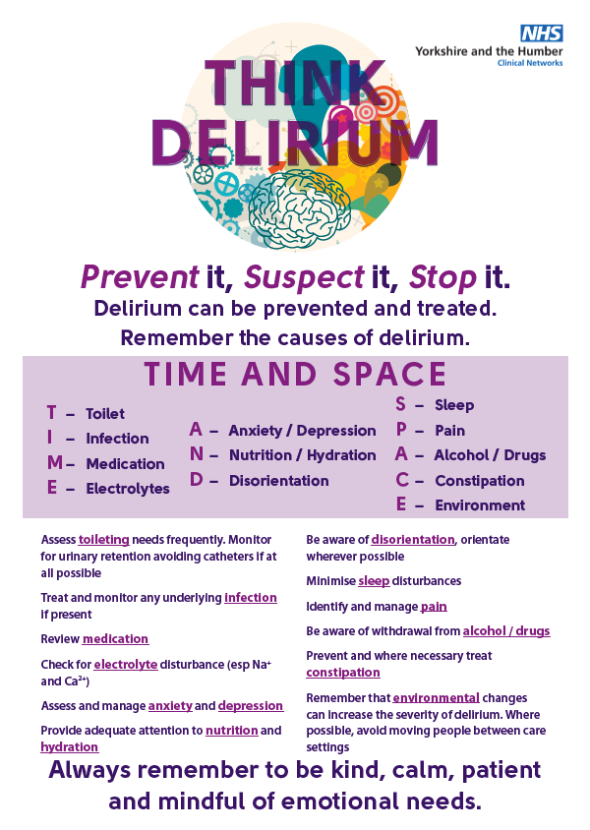

Appendix 5 – Five for falls

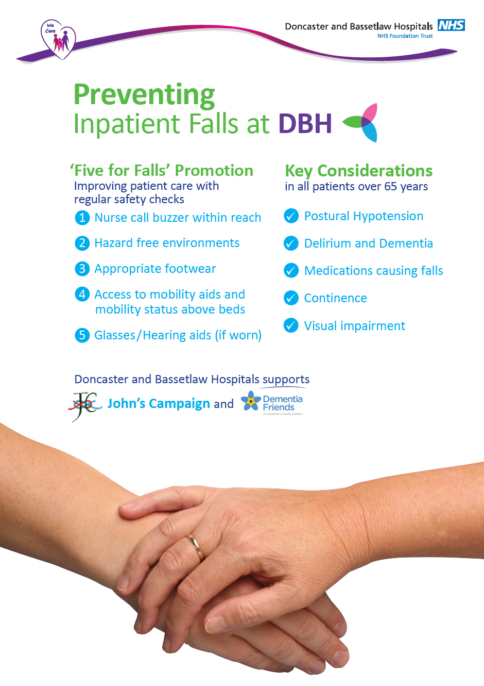

APPENDIX 6 - Equality Impact assessment part 1 initial screening

Service/Function/Policy/Project/Strategy | Division/Executive Directorate and Department | Assessor (s) | New or Existing Service or Policy? | Date of Assessment
De-escalation Policy | Corporate Nursing | Bethany Cotton | Revised policy | 01 June 2022
- Who is responsible for this policy? Name of Divisional Directorate: Corporate Nursing
- Describe the purpose of the service / function / policy / project/ strategy? To provide Trust staff with supportive guidance on de-escalating patients and when and how to use restraint within legal parameters
- Are there any associated objectives? Compliance with Care Quality Commission, Safeguarding Laws and Human Rights
- What factors contribute or detract from achieving intended outcomes? Effective communication between staff, patients, families and relevant parties.
- Does the policy have an impact in terms of age, race, disability, gender, gender reassignment, sexual orientation, marriage/civil partnership, maternity/pregnancy and religion/belief? No
- If yes, please describe current or planned activities to address the impact
- Is there any scope for new measures which would promote equality?
- Are any of the following groups adversely affected by the policy?
Protected Characteristics | Affected? | Impact
- Age | No
- Disability | No
- Gender | No
- Gender Reassignment | No
- Marriage/Civil Partnership | No
- Maternity/Pregnancy | No
- Race | No
- Religion/Belief | No
- Sexual Orientation | No
- Provide the Equality Rating of the service / function /policy / project / strategy – tick () outcome box
Outcome 1 | Outcome 2 | Outcome 3 | Outcome 4
*If you have rated the policy as having an outcome of 2, 3 or 4, it is necessary to carry out a detailed assessment and complete a Detailed Equality Analysis form – see CORP/EMP 27.
Date for next review: March 2022
Checked by: Marie Hardacre Date: 29 June 2022

