
Children’s Speech & Language Therapy Service

Speech Sound Screen
Tel: 01302 642633
Introduction and Guidance on using the Speech Sound Screen
The Speech Sound Screen will help you to identify when to refer to the Speech and Language Therapy Service.
Each picture contains one target sound. These are clearly identified on the assessment form provided.
Target Sound | Initial Sound |  | Medial Sound |  | Final  Sound
p | peas |  | nappy |  | Zip

Point to each picture and ask the child to name it. If they are unsure try to give them clues e.g. it’s an animal that goes ‘oink’. You may need to prompt them further e.g. ‘is it a pig or a chair’.
Use black ink to tick appropriate box if the child says the word correctly.
Target Sound | Initial Sound |  | Medial Sound |  | Final  Sound
p | peas |  | nappy |  | Zip

If the child cannot say the word/s correctly, try to write down how it sounded, as best you can.
Target Sound | Initial Sound |  | Medial Sound |  | Final  Sound
p | peas | bee | nappy | nabby | Zip | Zi

to watch a helpful video

(ADD D&Cs Teeside video)

Children’s Speech & Language Therapy Service

Speech Sound Screen
Tel: 01302 642633

Completed Speech Sound Screen
Once you have completed the Speech Sound Screen please use the Norms Chart Below to identify if they do have speech sound difficulties and if a referral to the service is needed.
Sounds | Average Age of Acquisition
m, n, w, b, d, h, p, t, y | 3 years
m, n, w, b, d, h, p, t, y, k, g, f, s, ng (swing) | 4 years
m, n, w, b, d, h, p, t, y, k, g, f, s, ng (swing), sh, v, z | 5 years
m, n, w, b, d, h, p, t, y, k, g, f, s, ng (swing), sh, v, z, l, ch, j, s blends (spoon), l blends (blue) | 6 years
m, n, w, b, d, h, p, t, y, k, g, f, s, ng (swing) sh, v, z, l, ch, j, s blends (spoon), l blends (blue), r, th, r blends (frog) | 7 years
*Based on McLeod and Crowe (2018)

When to refer to Speech and Language Therapy

From 3 years onwards many sounds are establishing in a child’s speech sound systems, including end sounds. It is common that ‘f’, ‘s’, ‘k’ and ‘g’ are problematic but these are more accurately used by the age of 4 years.
Children should be able to say many sounds correctly by the age of 4+ years, however, it is common they may still have difficulty with the sounds
- ‘r’, ‘sh’, ‘j’, ‘ch’, ‘th’
- consonant blends e.g. spoon, star, smile
- r blends e.g. brush, cry, crown
- l blends e.g. cloud, flower
Refer to Speech and Language Therapy at 4+ if child has difficulty with other sounds than those identified above i.e. difficulties with p, b, t, d, k, g, f, s.
Refer to Speech and Language Therapy at 6+ if child has difficulties with r, l, th, l blends, r blends.

Children’s Speech & Language Therapy Service

Speech Sound Screen
Tel: 01302 642633
Indicators for Referral

- The child is difficult to understand by main care giver.
- The child is frustrated/distressed by their speech.
- No use of initial or final sounds.
- A predominance of one sound e.g. four – door, sock – dock, pie –die, shoe-do, car-dar.

Don’t refer if

- Dribbling, drooling, congestion only.
- A child with a tongue-tie with no eating, drinking or speech difficulties.
- Lisps if adult teeth are not in place and/or child has no awareness of or motivation to use a clearer ‘s’.
- Accent/dialect substitutions e.g. thumb – fum, thing – fing.
- If a child is experiencing only a mild delay for their age e.g. only just turned 5 years of age and not consistently using ‘s’ blends.

Children’s Speech & Language Therapy Service

Speech Sound Screen
]
Tel: 01302 642633

Speech Sound Assessment Recording Sheet

Child’s Name:…………………………………………………… DOB:………………………………….. Age:…………………………………

Completed by:………………………………………………….. Date:……………………………………………………………………………
Target Sound | Initial Sound |  | Medial Sound |  | Final Sound
m (3 years) | milk |  | camel |  | jam
n (3 years) | net |  | honey |  | bin
w (3 years) | worm |  | towel
b (3 years) | boat |  | baby |  | crab
p (3 years) | peas |  | nappy |  | zip
t (3 years) | two |  | button |  | cat
d (3 years) | duck |  | ladder |  | bed
h (3 years) | horse
y (3 years) | yogurt
k (4 years) | key |  | rocket |  | sock
g (4 years) | ghost |  | tiger |  | bag
f (4 years) | four |  | dolphin |  | leaf
s (4 years) | sausage |  | castle |  | mouse
ng (4 years) |  |  | finger |  | ring
sh (5 years) | shoe |  | fishing |  | brush
v (5 years) | volcano |  | driving |  | five
z (5 years) | zebra |  | lizard |  | cheese
l (6 years) | lion |  | toilet |  | bell
ch (6 years) | chocolate |  | kitchen |  | witch
j (6 years) | giraffe |  | Fire engine |  | bridge
r (7 years) | red |  | pirate
th (7 years) | thumb |  | feather |  | bath
s blends (6 years) | scarf |  | Comments/Observations: (can the child copy any sounds said in error e.g. if the child says ‘tar’ for ‘car’ can they copy a correct ‘k’ sound or say the word ‘car’ when it is modelled by an adult).
s blends (6 years) | star
s blends (6 years) | spoon
l blends (6 years) | plate
l blends (6 years) | blow
l blends (6 years) | cloud
r blends (7 years) | grass
r blends (7 years) | drum
r blends (7 years) | frog

 | Initial | Medial | Final
m |  | 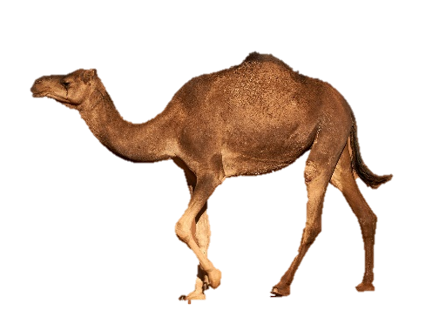 | 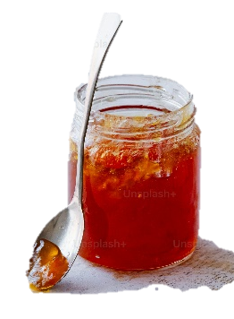
n | 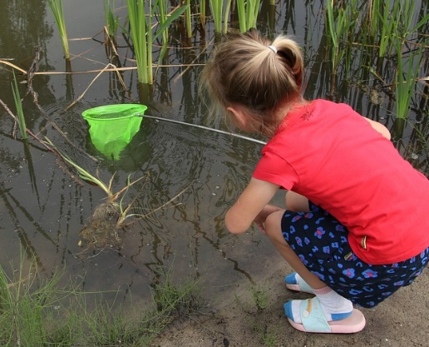 |  | 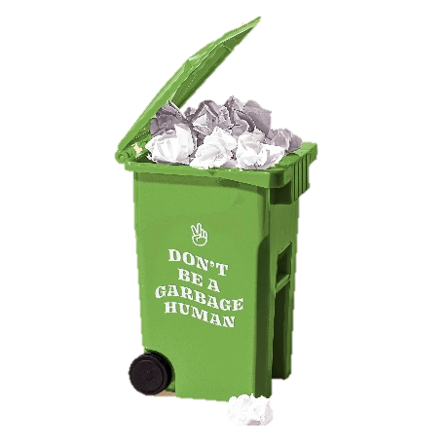
w | 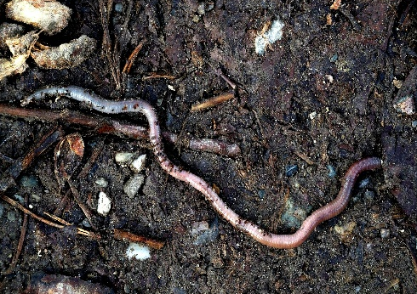 | 
b |  | 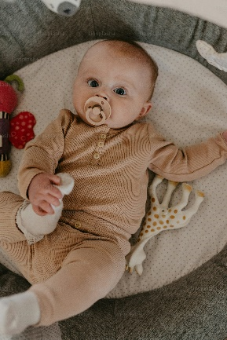 | 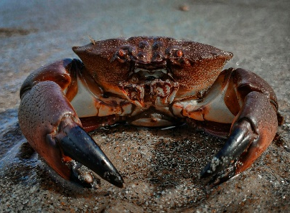

 | Initial | Medial | Final
p |  | 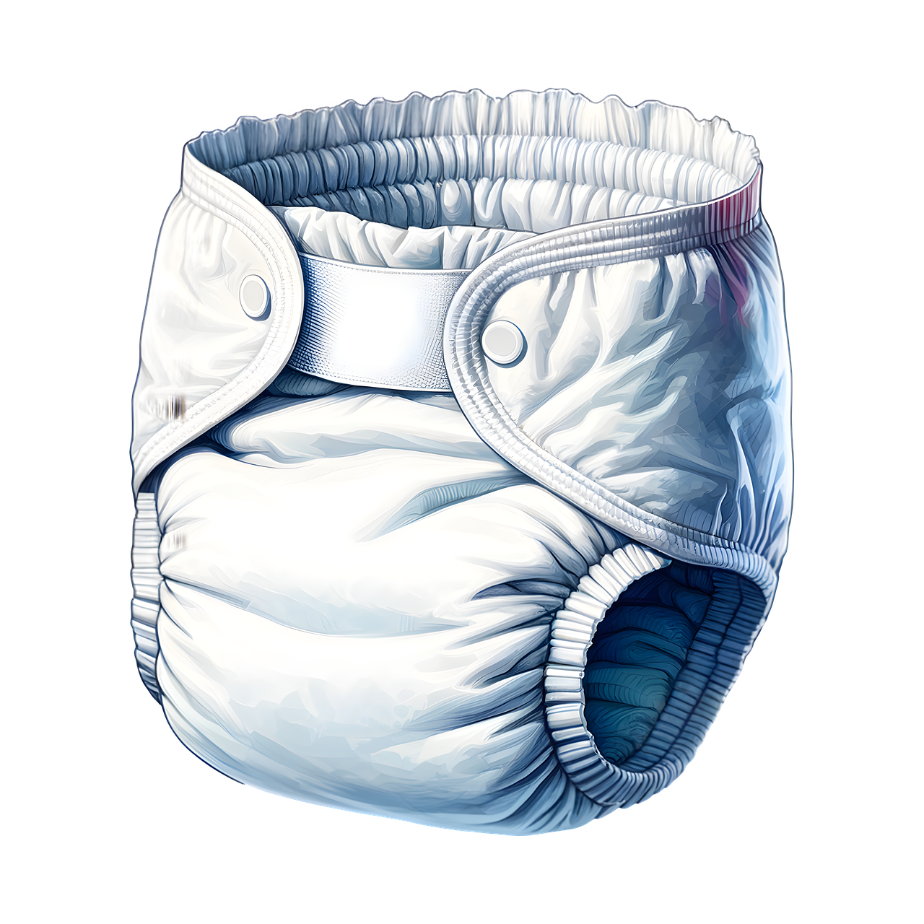 | 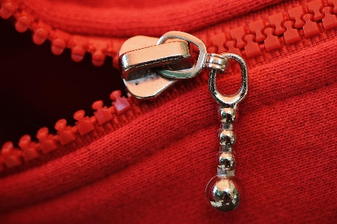
t |  | 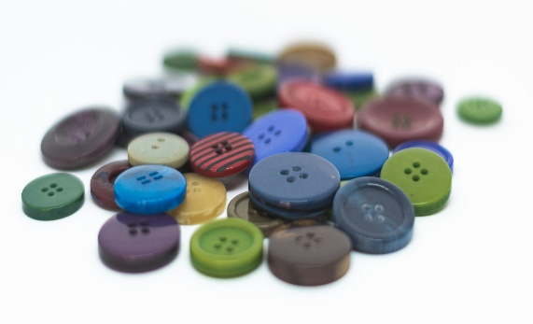 | 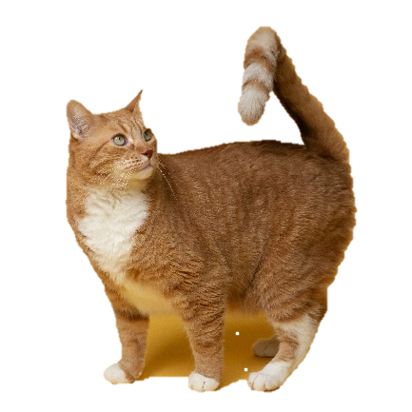
d | 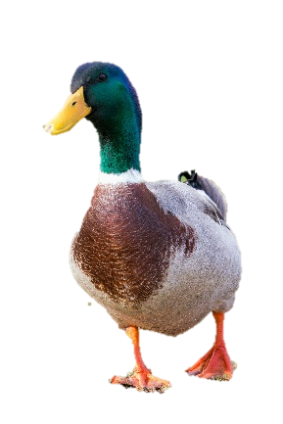 | 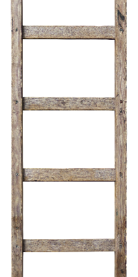 | 
h | 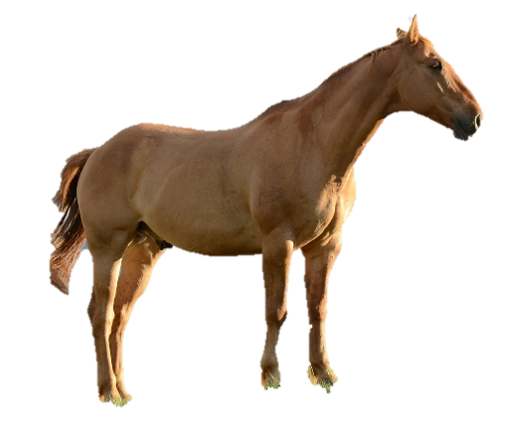

 | Initial | Medial | Final
y | 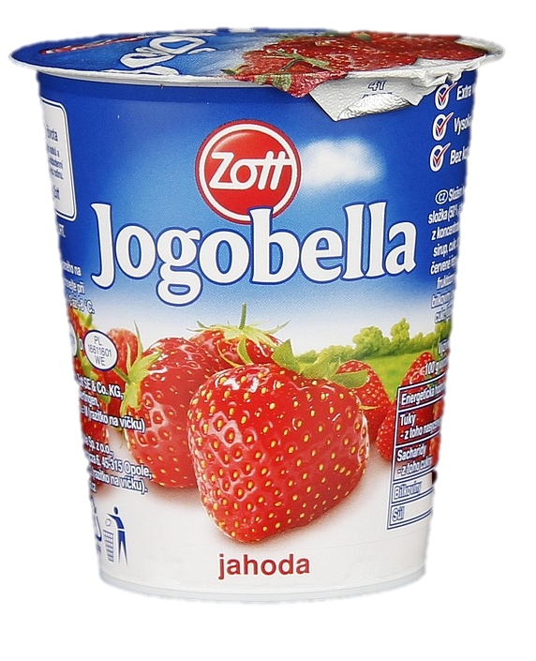
k | 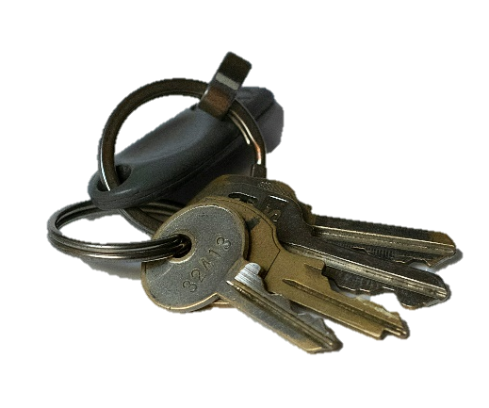 |  | 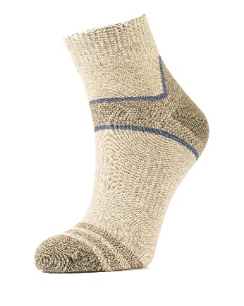
g |  |  | 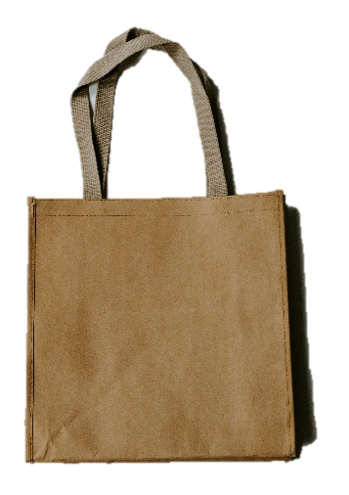
f | 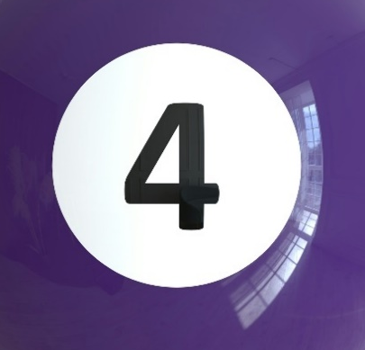 |  | 

 | Initial | Medial | Final
s | 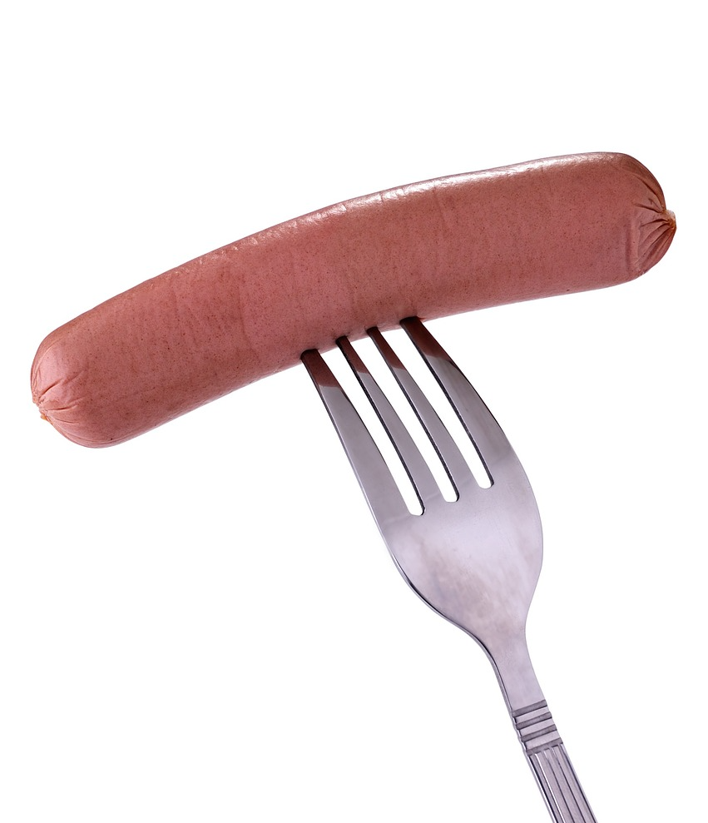 |  | 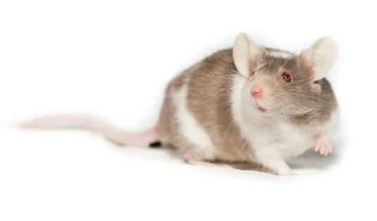
ng |  |  | 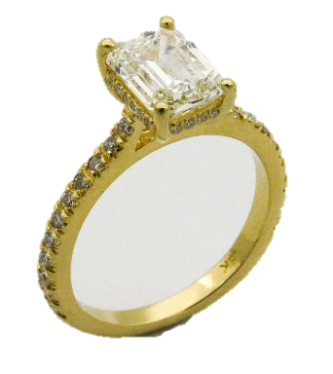
sh | 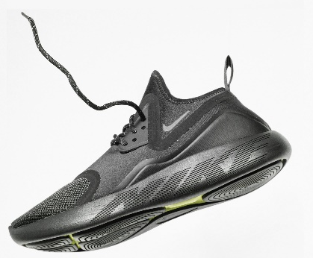 | 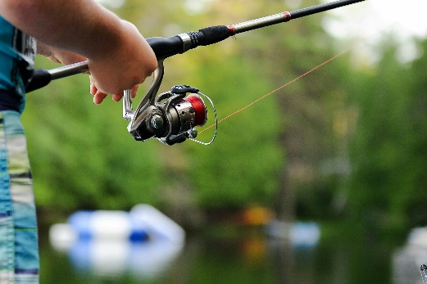 | 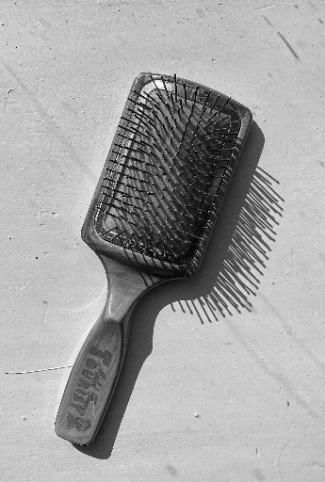
v |  |  | 
Z |  | 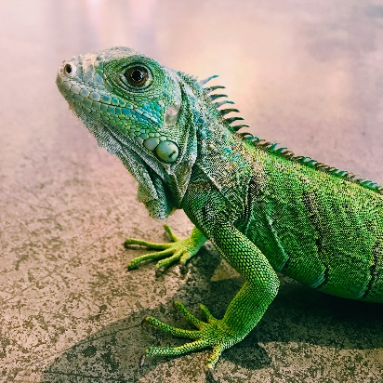 | 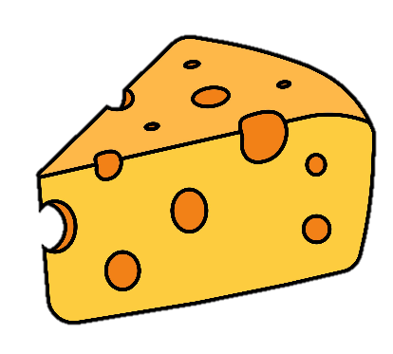

 | Initial | Medial | Final
l |  | 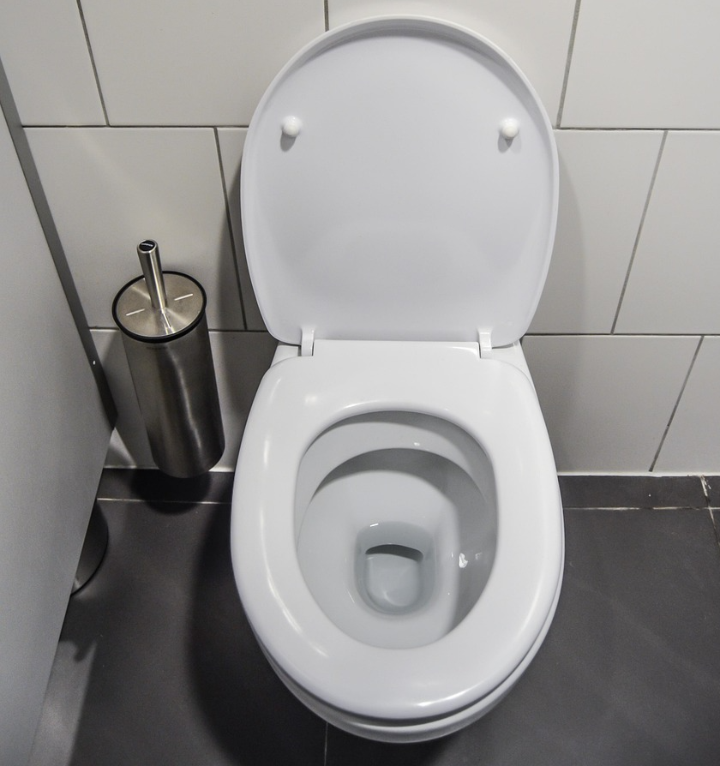 | 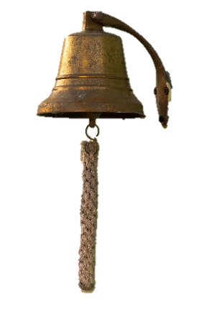
ch |  | 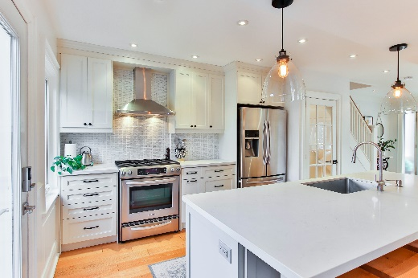 | 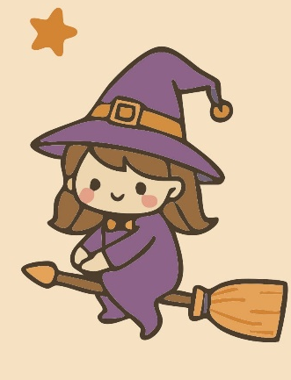
j | 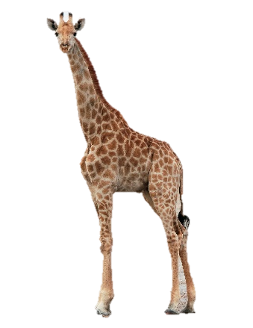 | 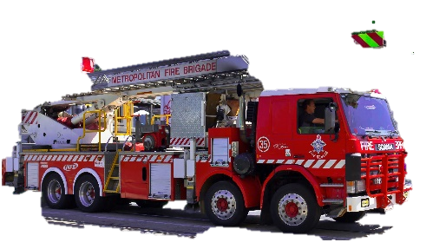 | 
r |  | 

 | Initial | Medial | Final
th |  | 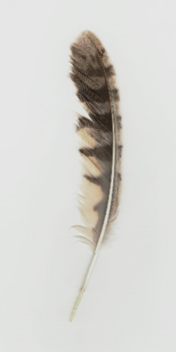 | 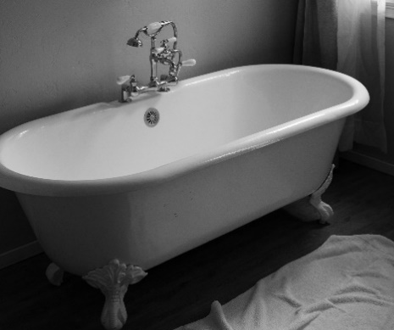
S blend |  |  | 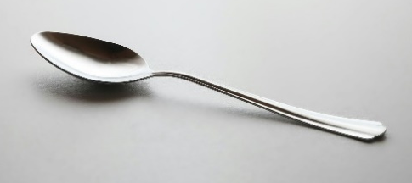
L blend |  | 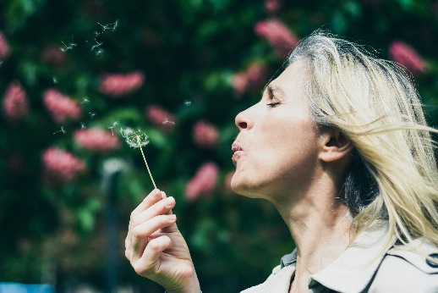 | 
R blend |  |  | 